**Databases I**

1. **Basic concepts**

* A database is an organised collection of related data:
  + presents aspects of the real world - Universe of discourse
  + Data has some inherent meaning
  + Is designed to be used for a specific purpose
* Databases are in the core of almost all computer systems
* Basic operations: Create, read, update, delete -CRUD
* Data storage requirements: scalability, performance even with big data sets, data integrity, concurrent access, structural changes need to be easy to implement, data protection, massive, persistent, safe, multi user, convenient, efficient, reliable
  1. **Two approaches for data storage** 
     1. **File processing approach (traditional)**
* Storing data as a list
* Flat file applications
* Each user has necessary files for its application -> each entity: separate files
* Tight coupling between physical and logical level

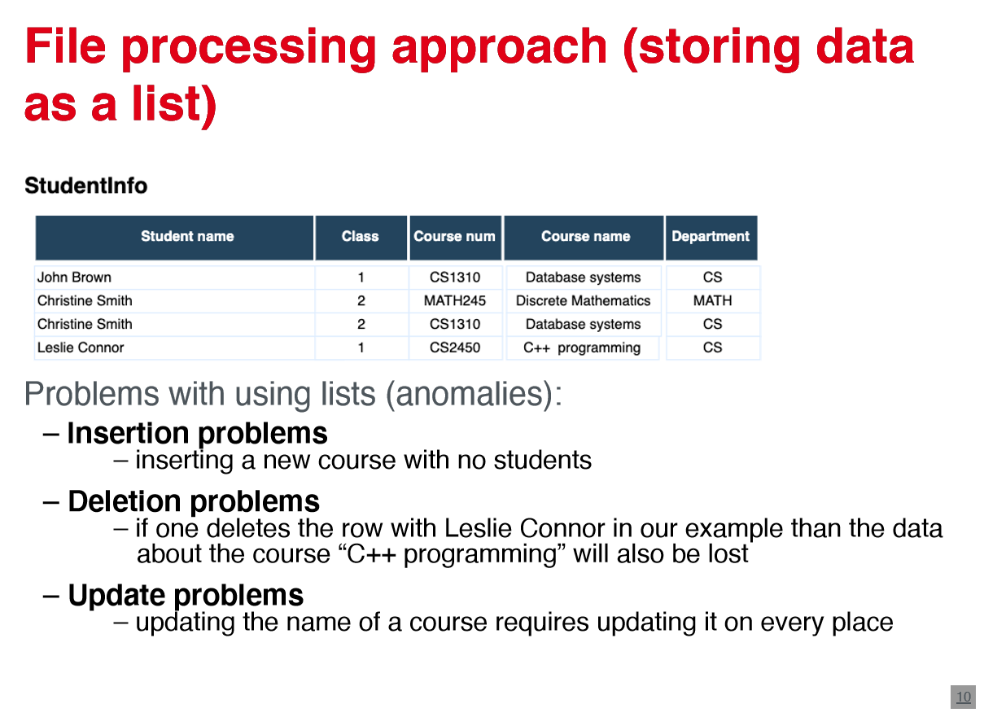

* + - 1. **Problems of using lists**
* Insertion, deletion and update problems -> Redundancy, inconsistency, limited access, problems for multi user access, data loss in crashes, integrity breach, security problems, development costs -> lack in flexibility
  + 1. **Database approach**
* Functions according to CODD: Integration, operations: CRUD, catalogue, user views, consistency, data protection, transactions, synchronisation, security
* Basic ideas: no redundancy, no unauthorised access, persistent storage for program objects, storage structures for efficient query processing, backup and recovery, multiple user interface, present complex relationships among data, integrity, permitting interfaces and actions using rules

1. Self describing nature of a database system (catalogue to store the database description- meta-data)



1. Insulation between programmes, data and data abstraction -> program-data-independence, program-operation-independence
2. Support of multiple views of the data
3. Sharing of data and multi user transaction processing - concurrency control (OLTP, OLAP)

**1.1.2.1 Database system environment**

* Consists of database system and database management system (DBMS)- software

**1.1.2.1.1 DBMS**



* General-purpose software that enables defining, constructing, manipulating and sharing databases
* Querying, update, administration of database
* Meta-data is stored by DBMS
* Allows users to interact with the database
* Situations inadequate: sometimes DBMS represents overhead
  + Embedded systems with limited storage capacity
  + systems of no multiple user access
  + many computer aided design tools
  + communication and switching systems
  + GIS system
* Modern architecture: basic client/server DBMS architecture
  + Client module: designed to work on user workstation
  + server module: handles data storage, access, search,…

**1.1.2.2. Key people**

* Database administrators: authorising access, monitoring database use
* database designers: creating design to meet requirements
* end user: querying, updating, generating report -> parametric (naive) user, casual user, sophisticated user
* system analysts and application programmers
* database system designers and implementers
* tool developers
  1. **. Data abstraction and data model**
* Data abstraction: way to suppress details of data organisation and storage to highlight essential features for an improved understanding of data
* data model: collection of concepts used for describing the structure of a database in order to achieve data abstraction
  + descriptions of data types, relations and constraints
  + description of basic operations
* database model: type of data model, which describes how a database is structured and used

**1.2.1. Categories of data models**

1. Conceptual (high level) data model:i.e. entity relationship

2. representational data models: relational data model

3. physical (low level) data models describe how data is stored as files: record formats. orderings

Further: relational, key/value, graph, document , column-family, array/metrics, hierarchical, network,…

**1.2.2. Database schema**



* Data model: database + description of database (database schema)
* Database schema (description) is specified during database design

-> not changed frequently, represented by schema diagrams

-> object of the schema: schema construct

-> also called “intension”

* DBMS:
  + maintain every database state as a valid state

-> database state: extension of the schema (it is changed constantly)

* + store schema constructs together with constraints

**1.2.2.1. Database state**

* Represents the data in the database at a particular moment (snapshot )

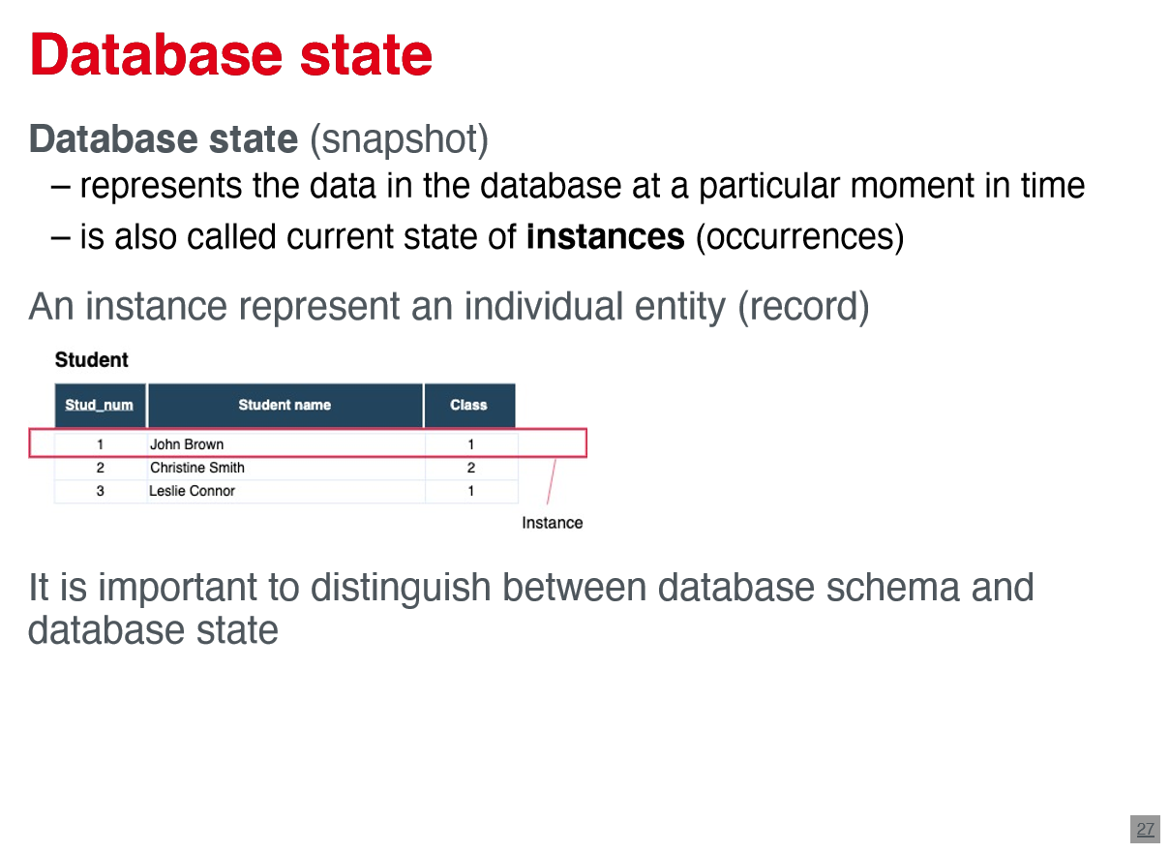

->current state of instances (occurrences )

* instance represents an individual entity (record )

**1.2.2.2. ANSI/SPARC architecture (Three-schema architecture )**



* Separate user application from physical database
* external (view) level: external schemas (user views) Describe the part of the database for a particular user group (representational )
* conceptual level :conceptual schema describes entities, Relationships , data types, user operations and constraints, described by representational model
* internal level: internal schema describes the physical storage structure and uses physical data model to describe details
* most DBMS support three-schema

**1.2.2.2.1 Data independence**

* capacity to change the schema at one level of a database system without having to change schema at the next higher level
* physical data independence : capacity to change the internal schema without having to change conceptual schema ->i.e. reorganising physical files
* logical data independence: change conceptual schema without changing external schema ,i.e. adding or removing constraints ,records types or data items ->harder to achieve ->mappings between layers are necessary

**1.2.3. Database languages**

* categories of query languages :
  + procedural (relational algebra )
  + non-procedural (declarative ): relational -calculus
* data definition language (DDL): DBMS use DDL to design conceptual and external schemas, have a DDL compiler
* data manipulation language (DML): used to manipulate the database (insertion, retrieval , deletion and modification )
  + high level : SQL: entered interactively or by general -purpose programming language
  + low level (procedural ): embedded in a general -purpose programming language ,retrieves individual objects and process them separately
* current DBMS use combination of DDL, VDL, DML

**1.2.4. DBMS**

* + - 1. **DBMS interfaces**
* Menu -based Interfaces for Web clients: parametric ,user friendly, helpful not to memorise specific commands
* Form-based interfaces : display forms with form field that should be filled and then matched in DBMS to retrieve data
* Graphical user interface: display schema in diagramatic form
* specific interfaces for parametric users
* natural language interfaces
  + - 1. **Classification of DBMS**
* Relational DBMS(RDBMS), object DBMS, object-relational DBMS, native XML DBMS, hierarchical DBMS, network DBMS

**1.2.5. Relational model**

* Storing database in simple data structures (tables ), access data through high -level language
* database is represented as a collection of relations :
  + table = relation , raw= tuple, column = attribute , data type of a column = domain
* Domaine D: set of atomic values (indivisible), Data types can be strings, integers , reals or specific values (zip-code, date, age)
* Realtion schema R: denoted by R = (A1, A2, … , An) -> relational name R and a list of attributes A1, A2, …,An
* Attribute A: role played by some domain D denoted by dom(Ai)
* Degree (or arity): number of attributes in a relation

**1.2.5.1 Relation(relation state)**

* A relation (realation state) r of a realtion schema R=(A1, A2,…,An) denoted as r(R) is a set of tuples r=t1,t2,…,tm
  + - Tuple is an ordered list t=<v1,v2,…,vn> of n values
    - vi ∈ dom(Ai) or vi is NULL as a special value
* Relation intension: relation schema R
* Relation extension: relation state r(R )
* Binary relation: R ⊆ {A × B}, R ⊆ {(a1, b1), … , (ak, bk)}
* N-ary relation: R ⊆ {A1 × A2 × … × An}
  + - r(R) ⊆ (dom(A1) × dom(A2) × … × dom(An))
    - total number of possible tuples ( rows) or cardinality of relation R is |dom(A1)|x |dom(A2)|x…x|dom(An)|, where |dom(Ai)|ist he cardinality of set Ai
* Interpretation: relations represent facts and relationships between entities, some attributes contain values of other relations -> relationship, closed world assumption ( facts in the database are the only true facts in the univers)

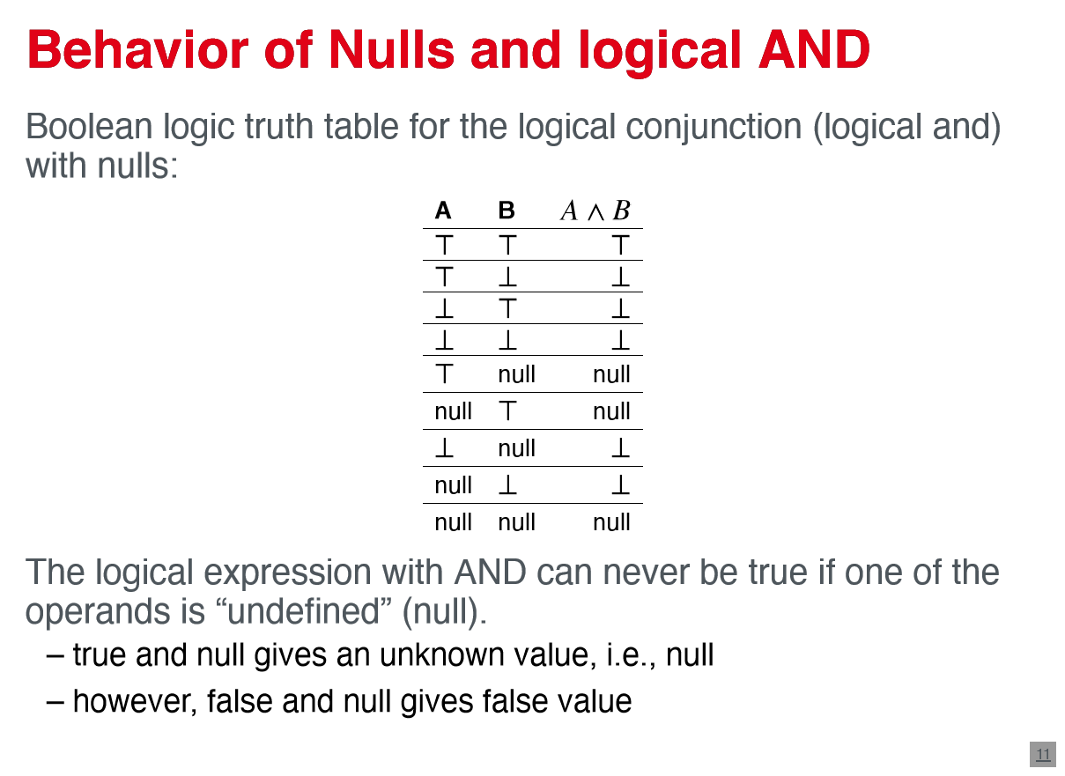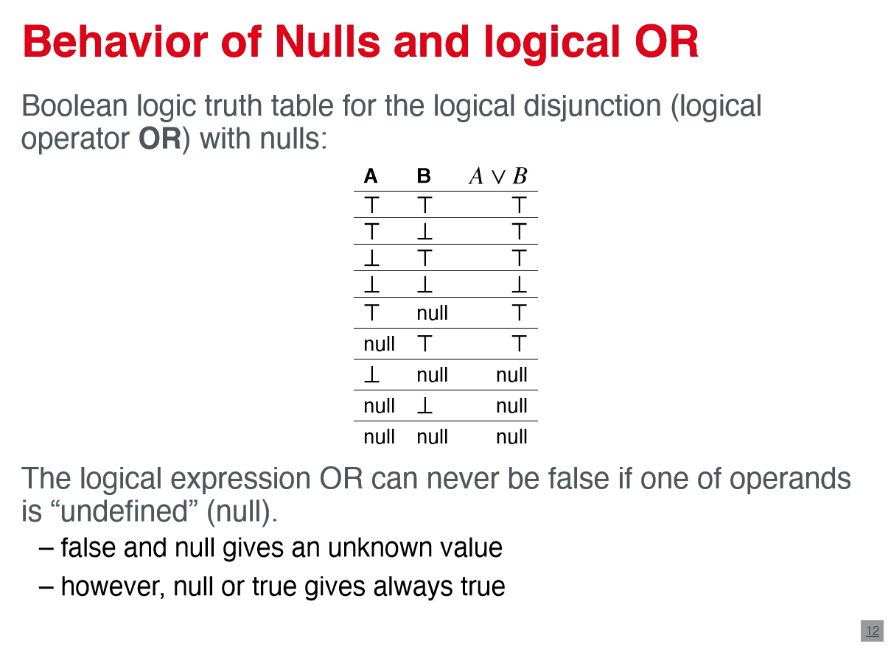

**1.2.5.1.1 Null values**

* Several meanings : value unknown , value exists but is not available , attribute does not apply
* if A and B are NULL, it doesn't mean they have the same value

**1.2.5.2 key constraints**

* relation : set of tuples -> all tuples must be distinct: ti[R] ≠ tj[R], ∀i, j, i ≠ j
* Super key : set of attributes in a relation schema R, in which all tuples are unique : ti[SK] ≠ tj[SK] -> Uniqueness constraint , i.e. (SSN, CLASS)
* key : a key K of a relation schema R is a super key of R with the additional property that removing any attribute A from K leaves a set of attributes K` that is not a superkey of R anymore
  + - two conditions : uniqueness , minimal superkey
    - a key is a super key but not vice versa
    - i.e. SSN, MATR_NUM



* candidate keys : all possible keys in the relation schema , SSN, MATR_NUM
* primary key : one of the candidate keys that is chosen to identify tuples in our relation -> other candidate keys = unique keys
* foreign keys: set of attributes FK in relation schema R1 is a foreign key of R2

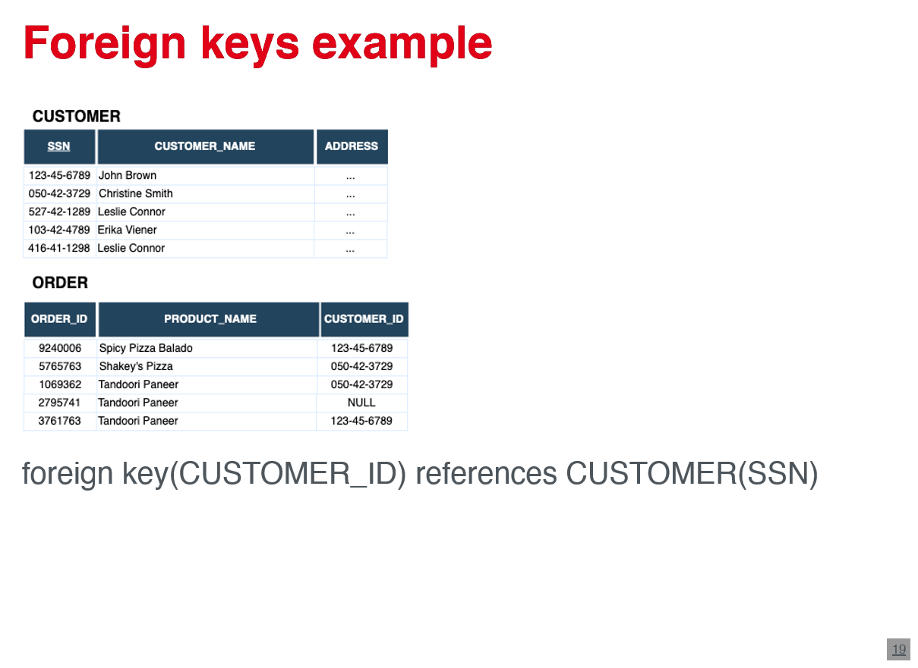

-> constraints: same domains , every tuple refers to a tuple, t1[FK]=t2[PK], i.e. Customer_ID to SSN -> referential integrity constraint

**1.2.5.3. functional dependency constraint**

* Functional dependency X->Y: ∀ti, tj ∈ r(R) : ti[X] = tj[X] ⟹ ti[Y] = tj[Y] – x and y are sets of attributes -> values of X uniquely determine values of Y
* i.e. SSN -> {SSN, MATR_NUM, Student_Name, Class}; {SSN, MATR_NUM}->{Class}

**1.2.5.3.1. Functional dependency inference rules (Armstrong's axioms)**

* Reflexivity: Y ⊂ X ⟹ X → Y
* Augmentation: X → Y ⟹ XZ → YZ
* Transitivity: X → Y ∧ Y → Z ⟹ X → Z
* Decomposition: X → YZ ⟹ X → Y ∧ X → Z
* Union: X → Y ∧ X → Z ⟹ X → YZ
* Pseudotransitivity: X → Y ∧ WY → Z ⟹ WX → Z

**1.2.5.4. Relational database schema**

* Relational database schema S:
  + Set of relation schemas S={R1,R2,…,Rn}
  + Set of integrity constraints IC
* Relational database state /instance of S:
  + set of relation states DB={R1,R2,…,Rn} -> ri Is a relation state of Ri: satisfy all constraints in IC
* Operations :
  + retrieval operations : see relational algebra
  + update operations :insert , update , delete

**1.2.5.5. relational algebra**

* Algebra = set off elements with executable operations {+,*}
* relational algebra = basic set of operations for relational model -> relational algebra expressions : used for SQL queries

**1.2.5.5.1. unary operations**

**1.2.5.5.1.1 Select operations (σ)**

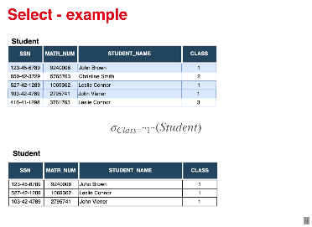

* Select a subset of tuples from relation that satisfies a selection condition : σ<selection−condition>(R)
* i.e. σClass=”3”(Student)
* in SQL : SELECT * FROM Employee WHERE Class=”3”

**Project operation (π)**

* Select a subset of columns from a relation: π<attribute_list>(R)

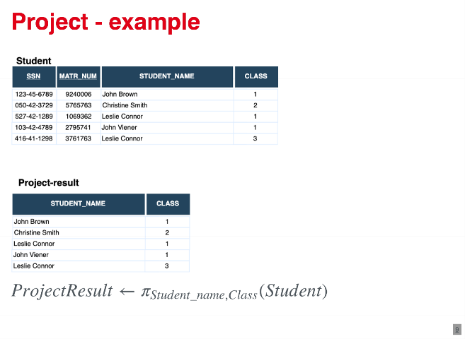

-> only selected attributes without duplicates in the tuples

* i.e. πStudent_name,Class(Student)
* in SQL: SELECT DISTINCT Student_name, Class FROM Employee

**Rename Operation (p)**

* Renames relation name or the attribute names or both ρS(B1,B2,…Bn)(R)
  + - * S: new relation; (B1,B2,…,Bn): set of attributes

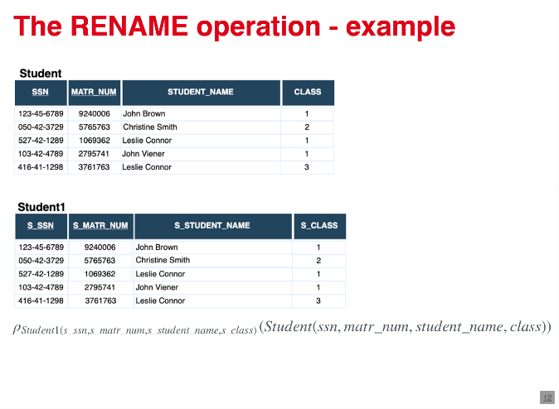

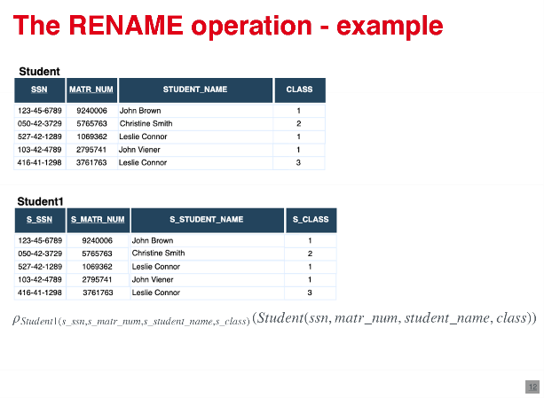

* i.e. PStudent1(S-ssn)(Student(ssn))
* in SQL: SELECT ssn AS s_ssn FROM Student AS Student1
  + - * 1. **Binary Operations**

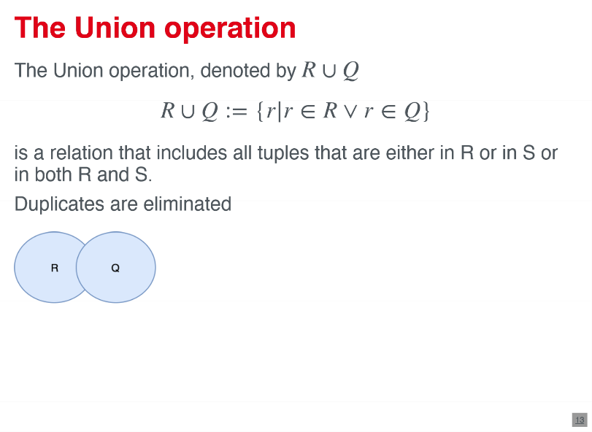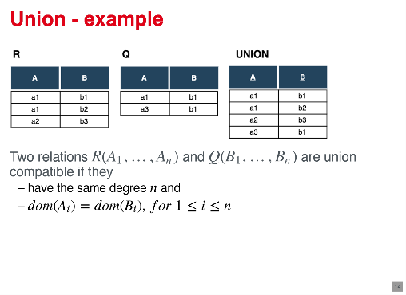

**Union operation**

* Includes all tuples that are either in R or in Q are in both
  + - * Duplicates are eliminated: R ∪ Q := {r|r ∈ R ∨ r ∈ Q}
* Two relations are union compatible if they have the same degree n and dom(Ai)=dom(Bi)

**Intersection operation**

* Includes all tuples that are in both R and Q -> R ∩ Q := {r|r ∈ R ∧ r ∈ Q}
* 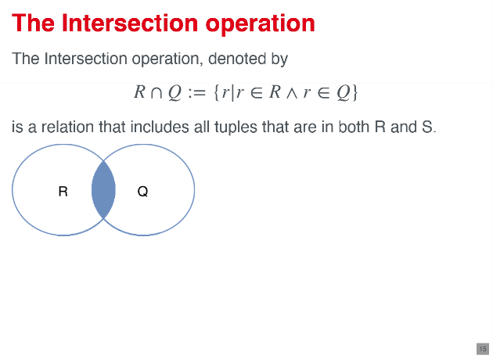

**Set difference (minus )operation**

* Includes all tuples that are in R but not in Q or vice versa -> R − Q := {r|r ∈ R ∧ r ∉ Q}
* |R − S| ≥ |R| − |S|
* 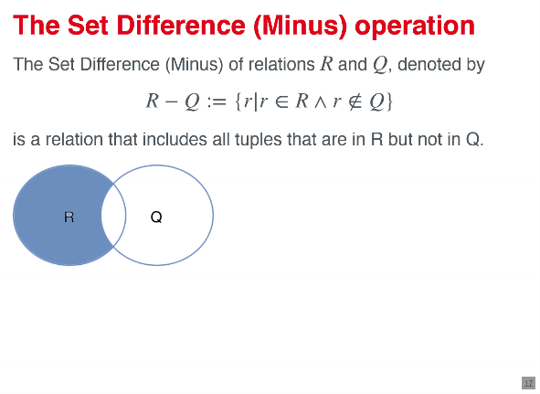

**cartesian product (cross product )**

* bolts all combinations of each to pull from R with all tuples from S: R × S
* degree n+m
* cardinality: |R × S| = |R| ⋅ |S|
* in SQL: SELECT * FROM Employee, Dependant

OR: SELECT * FROM Employee CROSSJOIN dependant

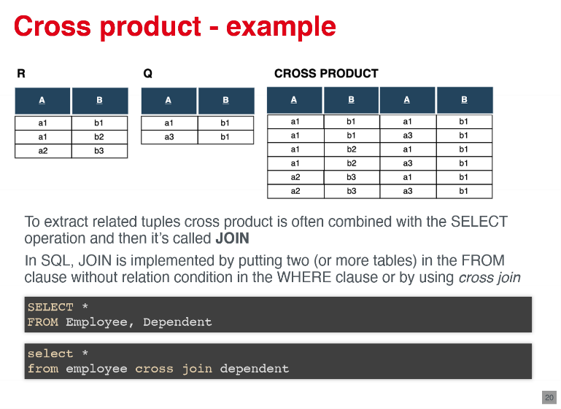

**Join operation**

* Builds one tuple for each combination of tuple from R and S, If the combination satisfies the join condition -> R ⋈<join_condition> S <-> σ<join_condition>R × S
* i.e. RESULT ← R ⋈R.A=S.A S
* 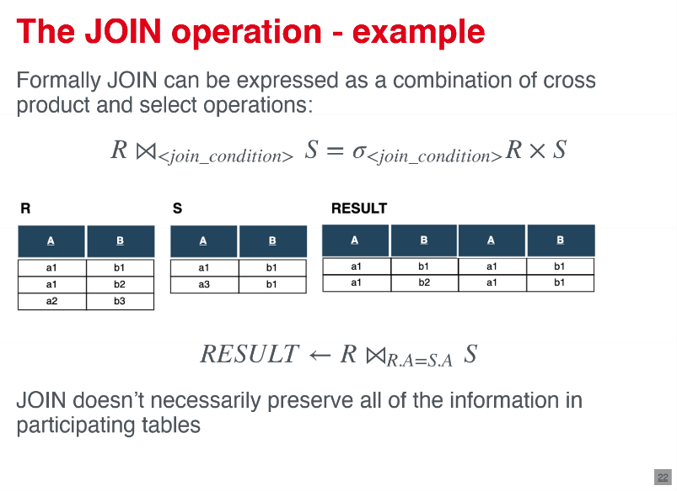
* also called THETA_JOIN - all conditions possible θ ∈ {=, <, ≤, >, ≥, ≠}
* EQUIJOIN: join operation with only condition : =
* 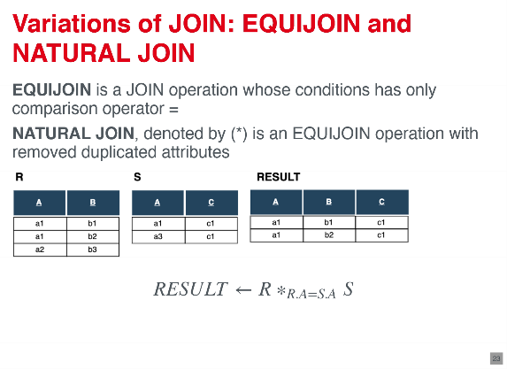
* natural Join: Equijoin removed duplicated attributes (*)

->Inner Join: because all tuples , which are not matching the conditions or have NULL are eliminated

**outer join :**

* keep all tuple in the left or right relation or in both, regardless if they match the condition or not
* left outer join : keeps every tuple in the left relation and fills the right relation attributes with NULL, if there is no matching
* 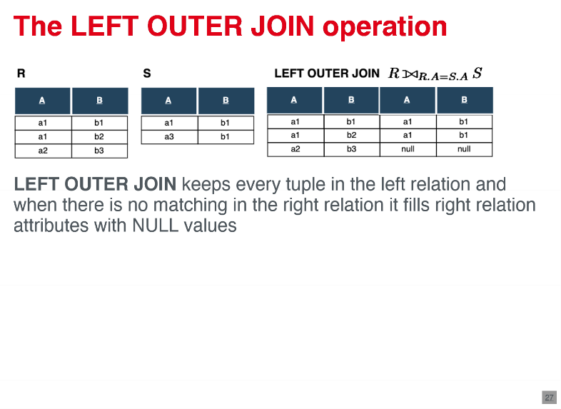
* right outer join : keeps ever tuple in the right relation and fill the left part with NULL, if there is no matching
* 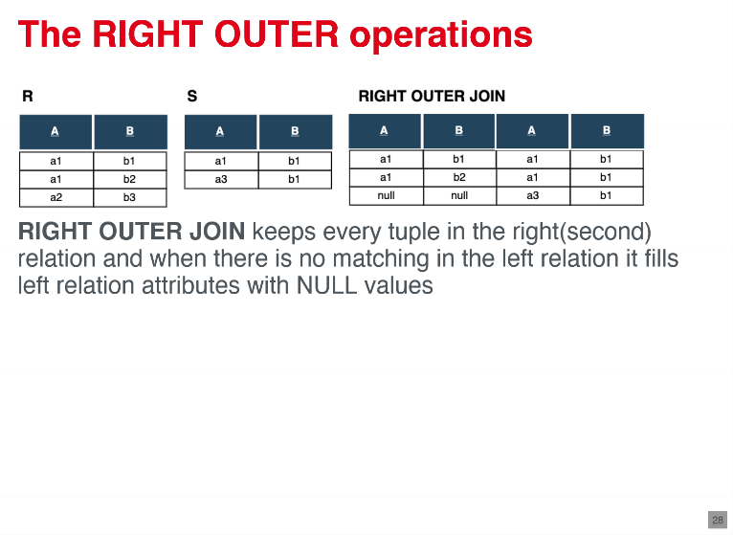
* full outer Join: keeps every tuple in both relation and fills missing values with NULL, if there is no matching

**division operation**

* applied to two relations R(Z) and S(X) where XcZ and gives as a result relation with attributes Y=Z-X -> a tuple t is in the result relation if tuples appear in R such that tR[y]=t
* 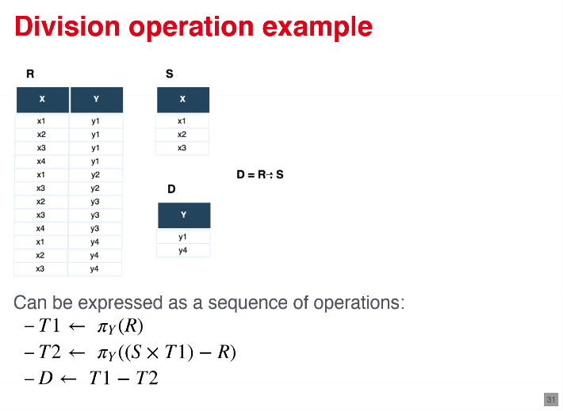

**aggregate function**

* Aggregate collections of values following functions: COUNT; SUM; AVERAGE ; MAX; MIN
* often combined with prior grouping attributes
* 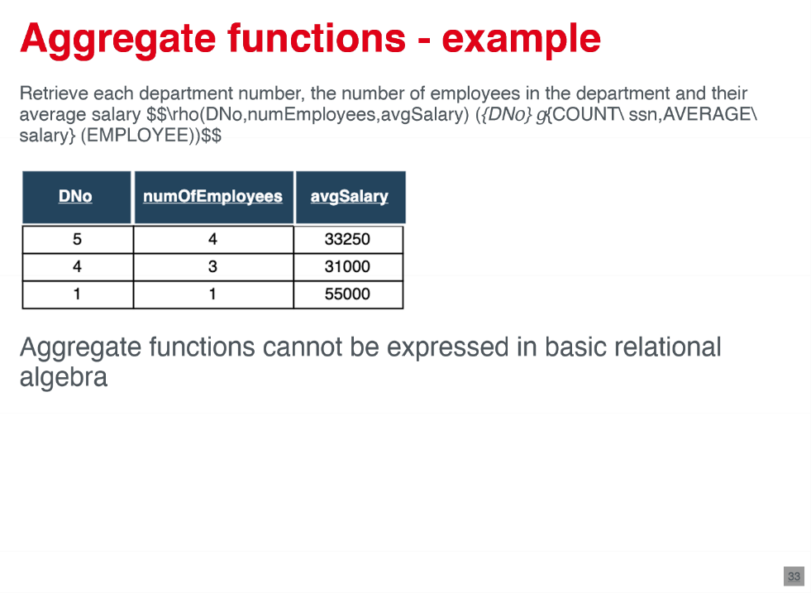
  1. **Database design**
* identifies necessary parts of the real world for the database ->transforms organization to a database schema

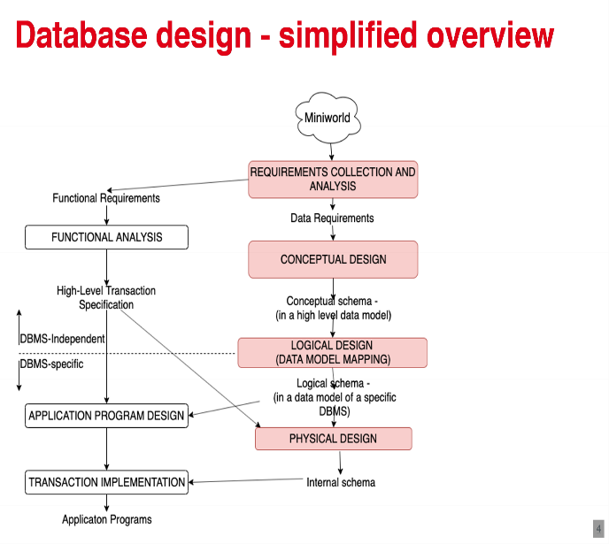

* possible that there are many correct database designs for an aspect of a mini world
* important to avoid redundancy (leads to inconsistency )and achieve completeness (otherwise there are several constraints )

1. requirements collection analysis

* interview with perspective users ->understand requirements
* documentation in different forms (dataflow , UML,..)

1. conceptual design

* transforming requirements to a conceptual schema -> ER-Diagramms, object relational mappings

1. logical design -data model mapping

* translation of ER-model to an implementation data model DBMS -> relational data model (SQL)

1. physical design

* specifying internal storage structures ,files ,indexes ,…

**1.3.1 Conceptual design – ER-modeling**

* entity relationship modeling : popular high level conceptual data model -> ER-diagrams : diagrammatic notation associated with the ER- model
* main elements : entities , attributes , relationships
  + entities : represent physical and conceptual objects from the real world
  + attributes : properties that describe objects (entities )
  + relationships : among entities
* different notations : Chen´s notation, UML notation, Crow´s Feet notation
* Name should convey the meanings of constructs (singular names )
* database design = iterative refinement process
  + refinement process from an initial design
  + inverse refinement

**1.3.1.1 entity types and sets**

* entity type = definition of collection of entities that have the same attribute -> described by its name and set of attributes ; rectangular box ; represents schema or intension
* entity set = collection of all entities of particular entity type -> each entity has its own values for each attribute , represents extension of the entity type
* 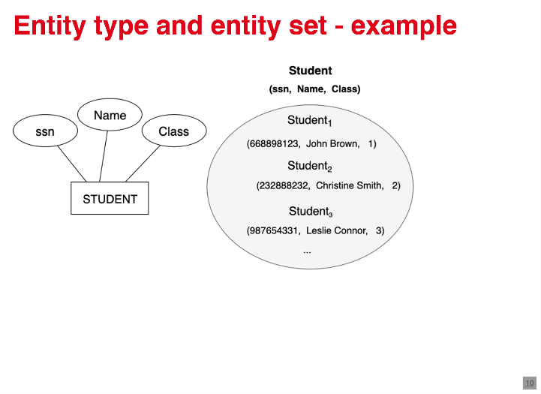

**1.3.1.1.1 weak entity types**

* entity type that doesn't have a key attribute
* weak entities belong to our specific entities of another entity type -> “identifying “ or “owner identity type “ and “identifying relation “ of that weak entity type
* total participation of the weak entity type to its identifying relationship
* weak entity types have up “Partial key”, which uniquely identifies them to some owners identity
* represented as boxes and diamonds with double lines
* 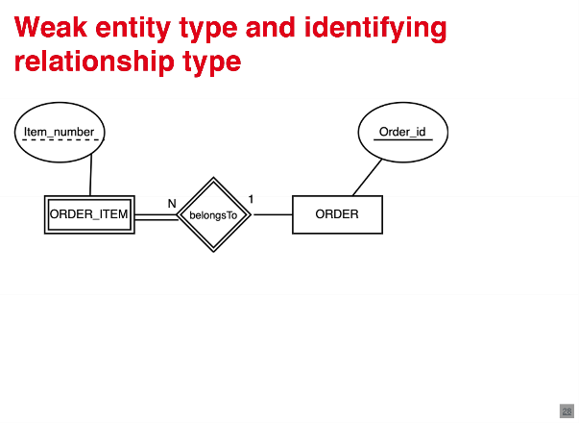

**1.3.1.1.2 generalization / specialization**

* generalization = way to represent subgroups of an entity type which are important for the database
  + an entity cannot exist just in the subclass
  + denoted as “is-a” or “part-of”
  + 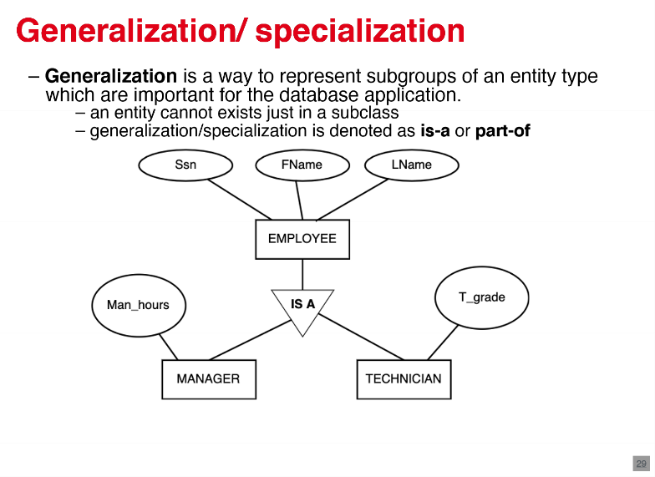

**1.3.1.2 Attributes**

* categories =atomic (not divisable ), composite, single valued , multivalued (number of values can be districted), stored (stored in the database), derived (values can be derived from other attributes )
* 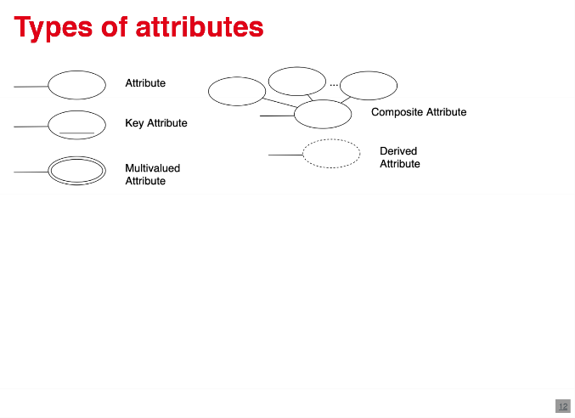

**1.3.1.2.1 key attributes**

* key attribute = set of attributes whose values are distinct for each individual entity in the entity set
  + uniqueness property , for composite attributes the unique with property must be minimal
  + underlined inside the oval
* natural key (business key )=unique identifier derived from data
* 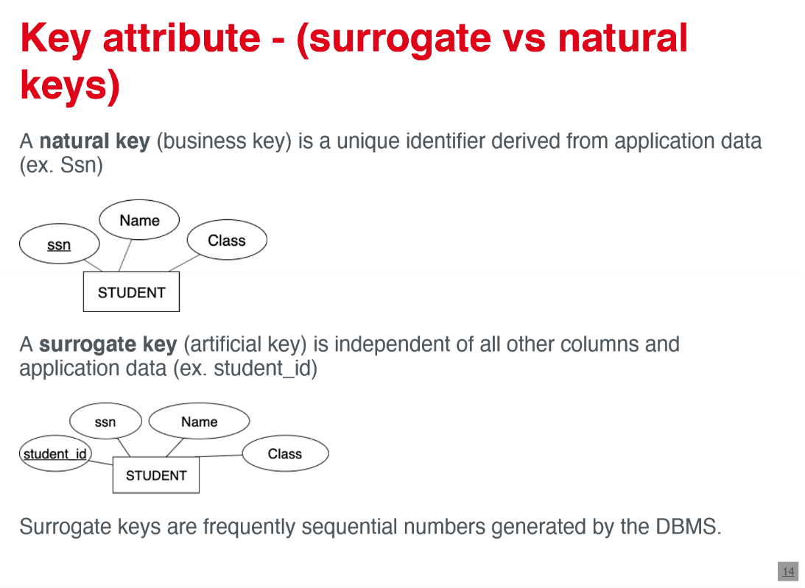
* surrogate key (artificial key )= independent all other columns and data -> i.e. sequential number generated by DBMS
* 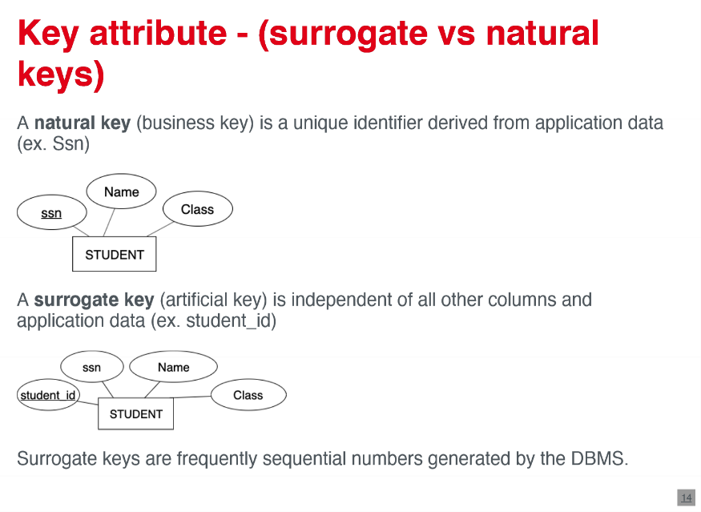
* domain of attribute = set of values that may be assigned to that attribute -> not displayed in ER-diagrams

**1.3.1.3 relationships**

* relationship instance = Association among entities (e1, e2, …, en), where each e1, e2, .., en belongs to an entity set
* relationship set = set up relationship instances - mathematical relation
* relation type = define the relationship set -> represented as diamond shaped boxes in ER

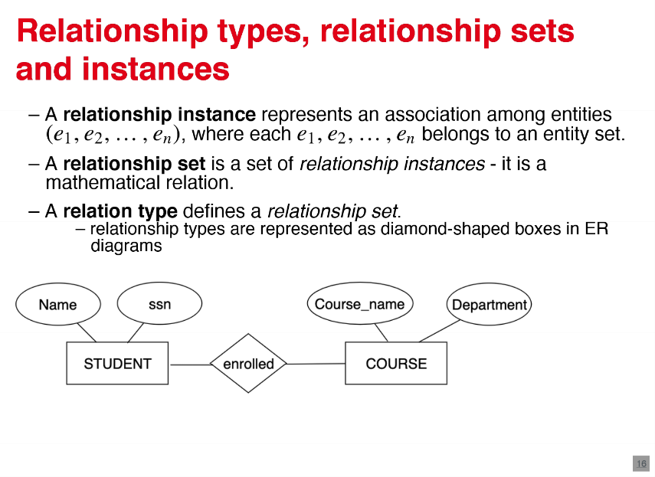

* relationship degree : number of participating entity types in the relationship
  + each participating entity is a “role” and a relationship
  + binary relationship : degree=2
  + ternary relationship : degree=3
  + n-ary relationships can be broken down into more relationships of smaller degrees , i.e. by introducing an surrogate key

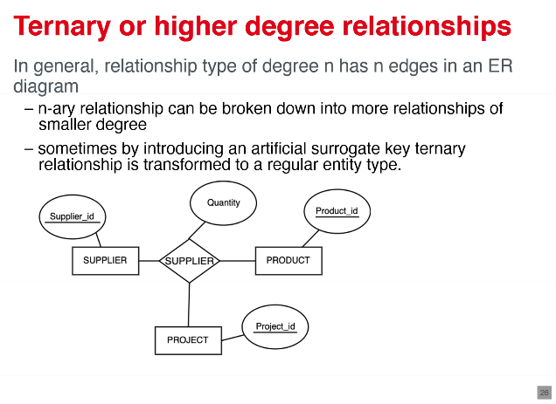

* recursive relationships : relationships in which some entities participate more than once

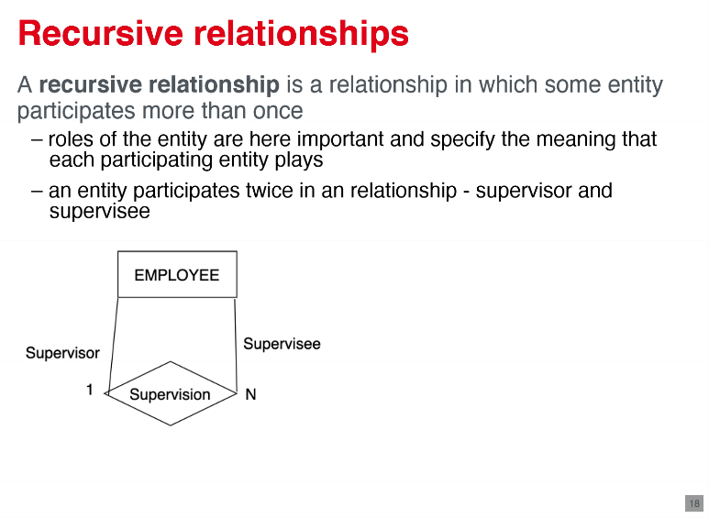

**1.3.1.3.1 Constraints on binary relationship types**

**1.3.1.3.1.1. cardinality ratio constraint**

* specify the maximum number of relationship instances entity can participate in
* possible cardinality relations : 1:1, 1:N, N:M
* 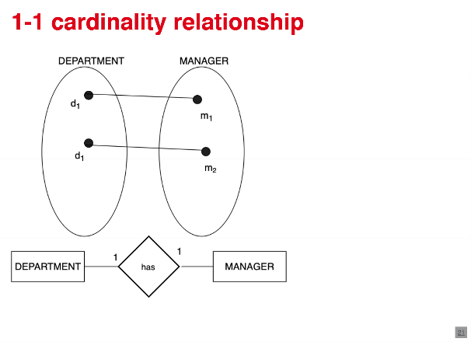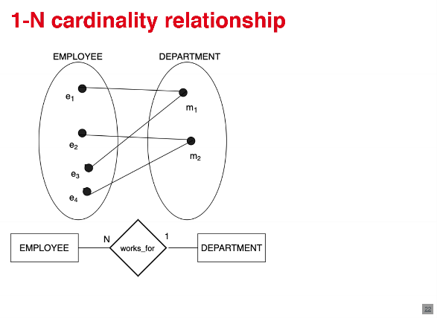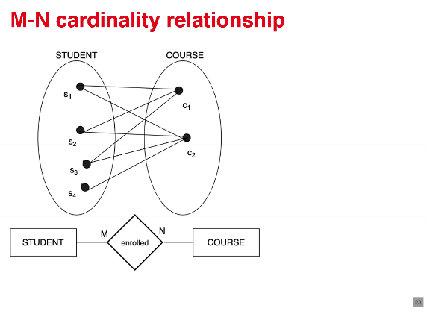

**1.3.1.3.1.2 Participation constraints**

* specify the minimum number for relationship instances that each entity can participate in
* possible participation constraints values : total , partial
  + total participation (existance dependency )is displayed as a double line connection
  + 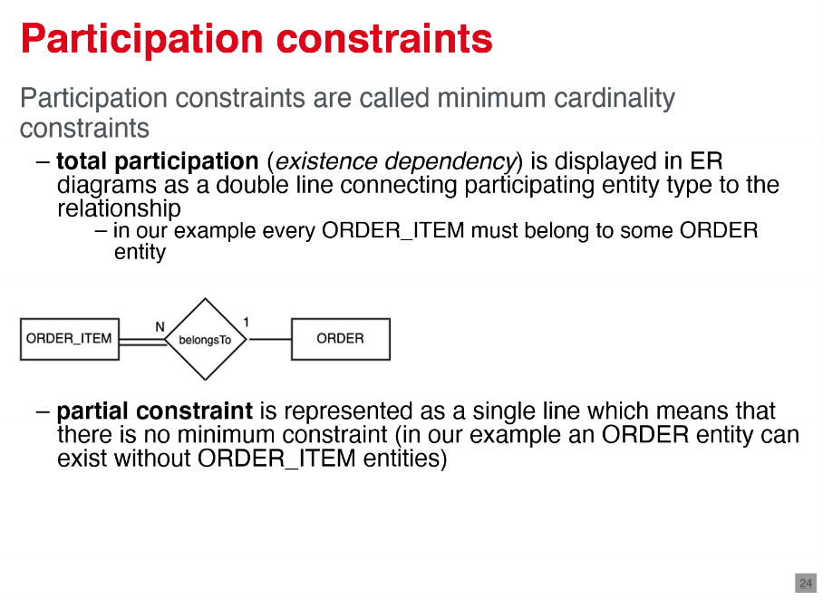
  + partial constraint : no minimum constraint ; displayed a single line

**1.3.1.3.2 attributes of relationship types**

* attributes of relationship types 1:1 and 1:N can migrate to participating entities
  + 1:1: migration to both sides possible
  + 1:N: migration only to N-Side possible
* attributes of M:N-relationships must be specified as relationship attributes

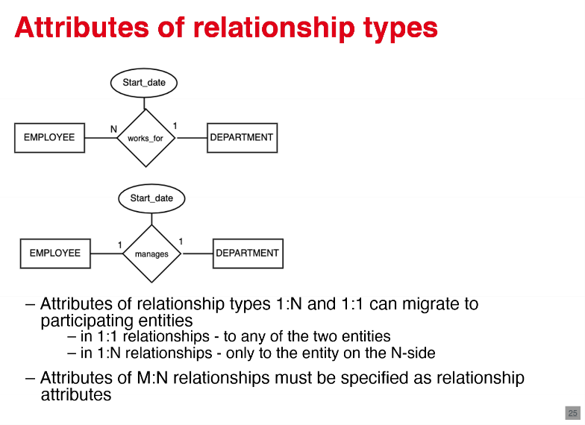

**1.3.2 logical design - relational model**

* conceptual schema ( ER-model) has to be transformed into a data model corresponding to DBMS tool (relational model ) -> mapping algorithm
* entity set corresponds to relational schema
* entity responds to Tuple
* relationship can be expressed using foreign keys

**1.3.2.1 mapping of entity types**

**1.3.2.1.1 strong entity types**

* algorithm creates for each strong entity type E a relation R
  + includes all simple attributes of E
  + simple component attributes of a composite attribute of mapped to attributes of R
  + one key of E is chosen to be primary key of R
  + knowledge about other keys is useful to specify secondary unique keys for indexes

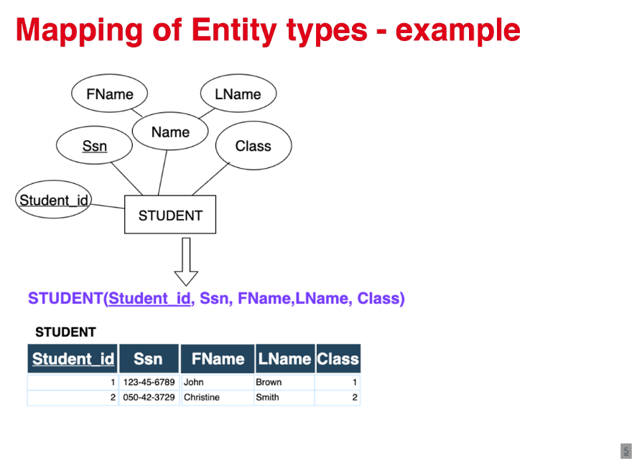

**1.3.2.1.2 weak entity types**

* for each week entity type W with owner type E algorithm creates a relation R
  + attributes of W : attributes of R
  + foreign key in R corresponding to primary key in E : implements the identifying relation -> comprised the primary key of R
* owner E should be mapped before the weak entity W to have primary key already determined

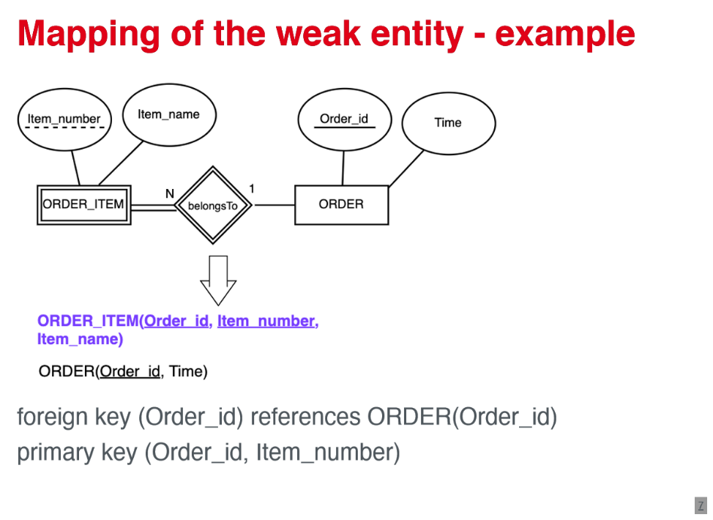

**1.3.2.1.3 Generalization / specialization**

* three approaches : multiple relations - super and subclass ; multiple relations - subclass only ; single relation

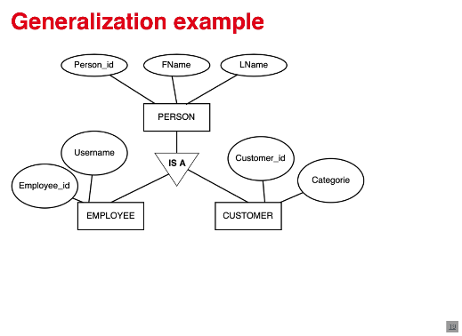

**1.3.2.1.3.1 multiple relations - superclass and subclass**

* primary key of subclasses is the same as primary key of the superclass
* i.e. person _ID is primary key in all relations

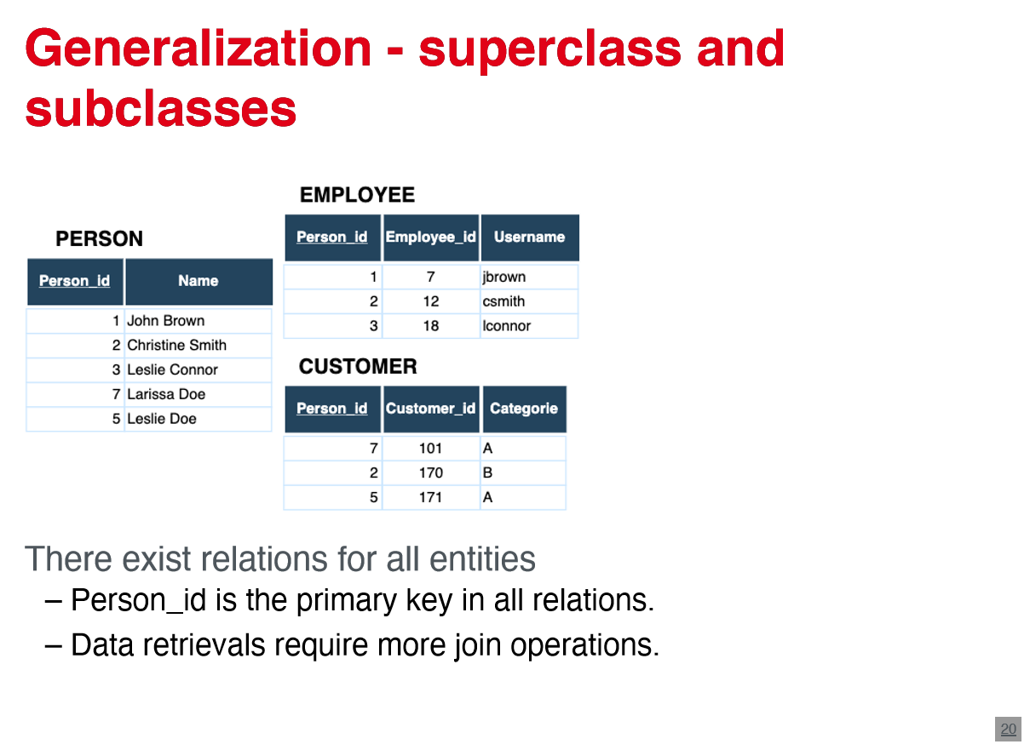

**1.3.2.1.3.2 multiple relations - only subclasses**

* only if each attribute of the superclass belongs to some subclass
* recommend when subclasses are disjoint
* primary key of super class = primary key of relations R

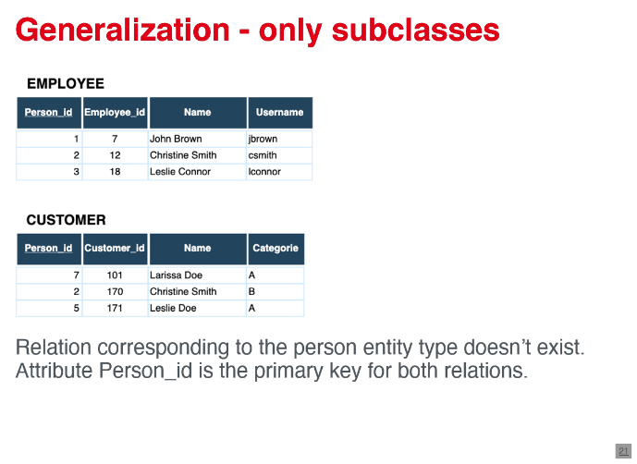

**1.3.2.1.3.3 single relations**

* only when subclasses are disjoint
* potential for generating many null values
* type or discriminating attributes points on the subset tuple belongs to

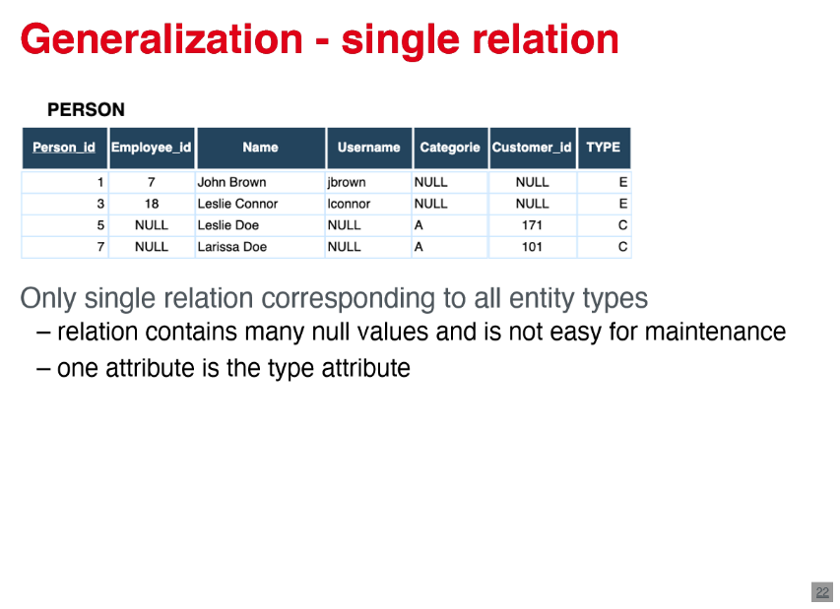

**1.3.2.2 mapping of multivalued attributes**

* a new relation is created for each multivalued attribute
* primary key of the entity gets included into the relation of the multivalued attribute -> to primary key comprise together with the original attribute of the multivalued attribute
* simple components are included if multivalued attribute is composite -> only some parts should be part of the primary key

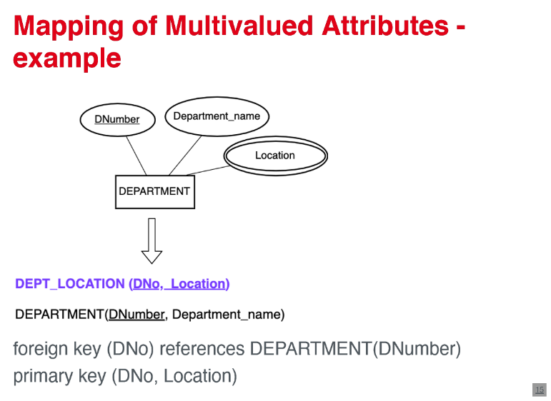

**1.3.2.3 mapping of relationships**

**1.3.2.3.1 1:1 binary relationship types**

1) foreign key approach : a relation to one of the participating entities (side with total participation ) get a foreign key that points on the primary key of the corresponding entity

2) merged relation approach : merging two entity types into a single relation - only if both participations are total

3) relationship relation approach : new relationship relation (look up table ) -> both primary keys of entities as foreign keys -> only one as primary key

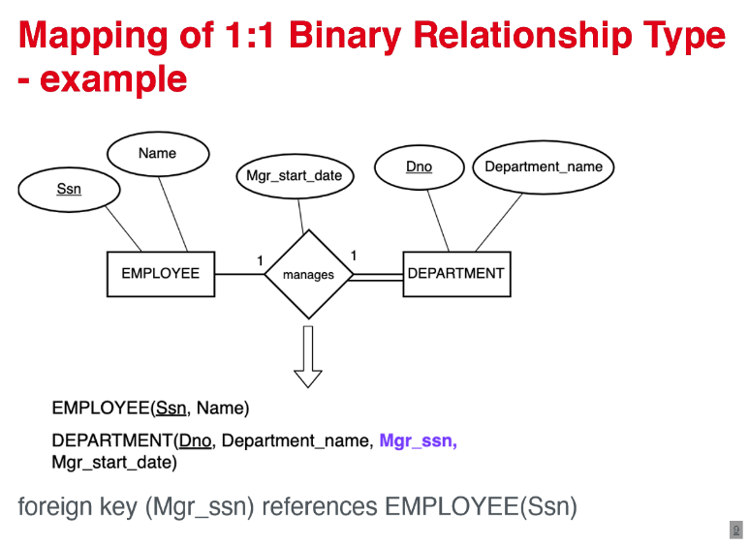

**1.3.2.3.2 1:N binary relationship types**

* relation of the entity type on the N-Side is changed
  + primary key of second relation is included as a foreign key
  + all simple attributes of relationship are included
* alternative : new relationship relation (look up table )is created -> too many nulls

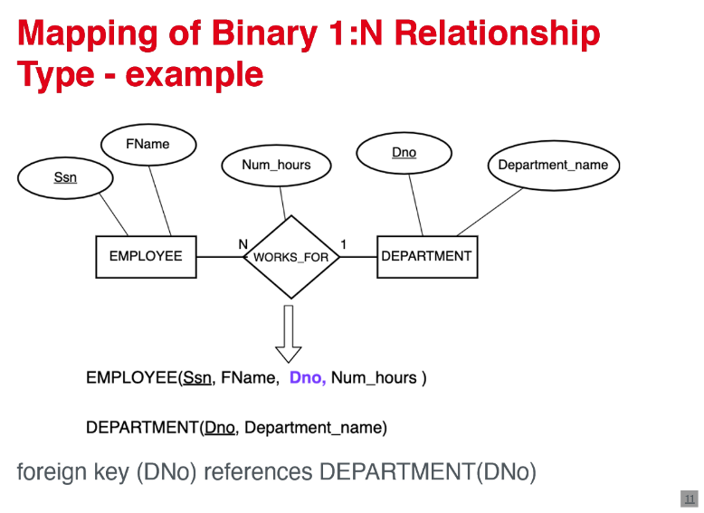

**1.3.2.3.3 N:M binary relationship**

* new relationship relation corresponding relationship type is created
  + primary key of entities are included as foreign keys -> combination of foreign keys creates the primary key of relation
  + all simple attributes are included
* propagation (CASCADE) call referentials triggered action on the foreign keys

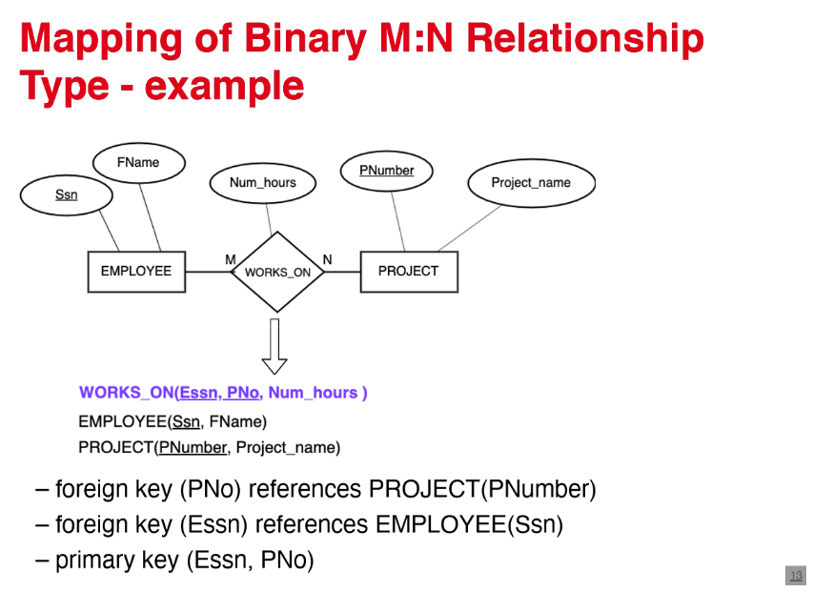

**1.3.2.3.4 N-ary relationship types**

* New relationship is created :
  + primary keys of participating entities are included as foreign key attributes
  + simple attributes and simple components are included
  + primary key is a combination of all foreign keys (exception if one of the entities has the cardinality one -> exclude from the primary key )

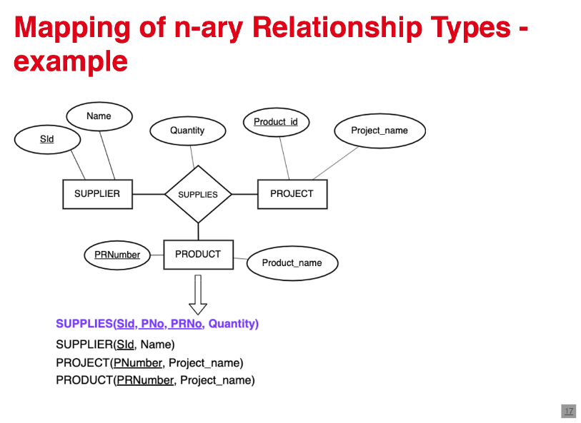

1. **SQL**

* SQL = Structured query language -> standard language for the DBMS
* SQL commands can be categorized into groups
  + DDL - data definition language : commands for creation
  + DML - data manipulation language : data retrieval and modification
* relation = table , Tuple = row, attribute = column
* declarative language : SELECT * FROM STUDENT
* database is a collection of tables and other constructs -> main container on an SQL environment : CREATE DATABES UNI
* database schema = name spectre contains named database , objects , views, indexes, etc. : CREATE SCHEMA administration
* CREATE TABLE = Specify a new relation (table )
  + attributes to have specific names and data types (int, char, varchar)
  + attributes are ordered accordingly to the creation

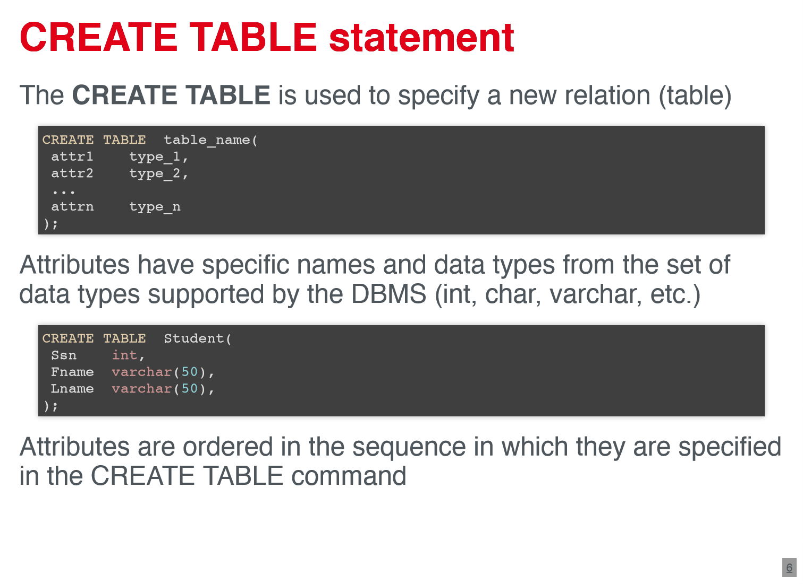

* 1. **Attribute data types and domains**
* basic data types :
  + numeric : INT; FLOAT; DECIMAL;…
  + Bit- string: BIT, BLOB, BINARY LARGE OBJECT
  + Boolean: True or False
  + Date: DATE; TIME; DATETIME
* Declaring new data type (domain ):
  + CREATE DOMAIN SSN_TYPE as CHAR(9)

**2.2 Constraints**

* Basic constraints are specified as part of table creation -> primary key , unique , not null, default , check , references
* check : Tuples are checked , whenever are inserted or modified - operator with check : =,<,>, <>, IN, BETWEEN, LIKE
* Primary key can contain multiple attributes
* for a key can be specified with references
* alternative definition of primary keys and foreign keys can be done with constraint -> not necessarily

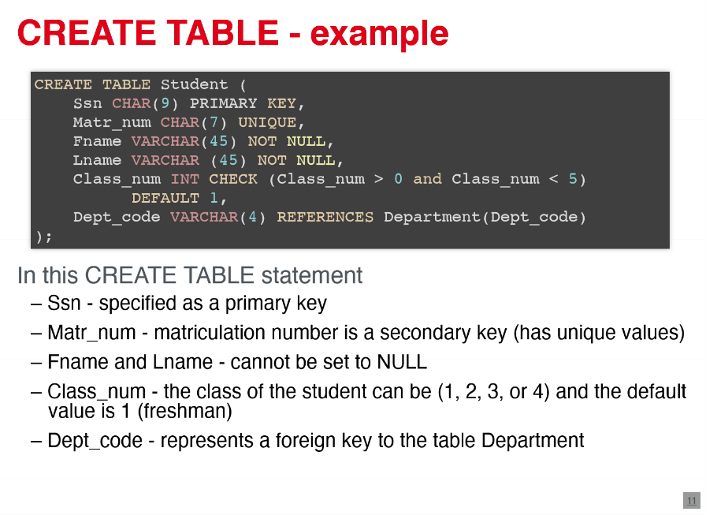 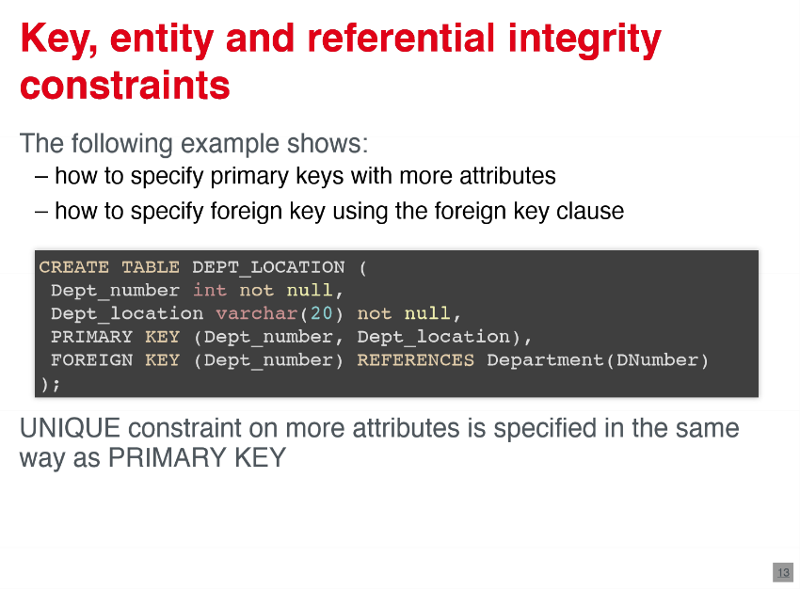

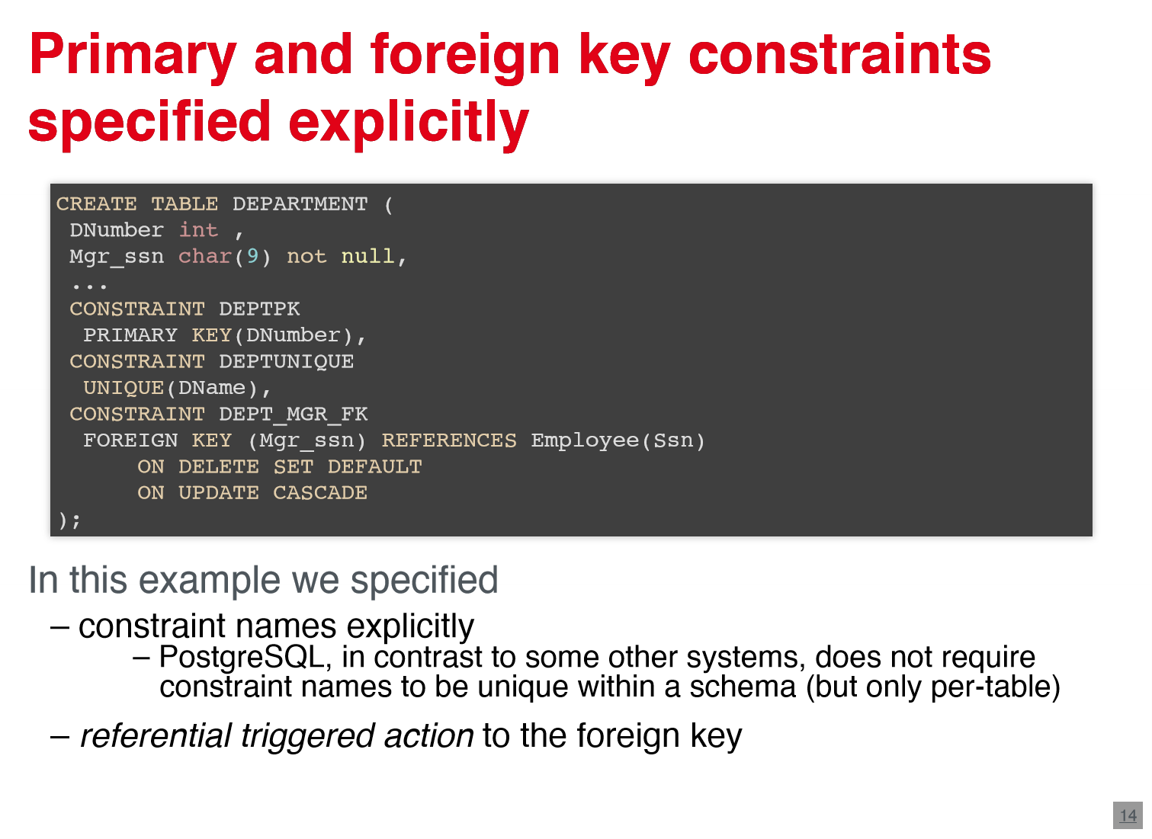

**2.2.1 referential triggered actions**

* referential trigger actions can be attached to any foreign key
  + ON DELETE: triggered on deletion -> CASCADE (Delete all related rows ), SET NULL; SET DEFAULT; NO ACTION
  + 2. ON UPDATE: triggered by updating -> CASCADE SET NULL; SET DEFAULT; NO ACTION

**2.3 Commands**

* DROP Commands are used to delete databases or elements -> DROP DATABASE databasename ; DROP TABLE table name
* ALTER table commands are used to change created tables: add new columns ,rename a table ,change a column or remove column ,add new constraints primary key and foreign key , drop constraints
* INSERT command is used to add tuples to a relation (row to a table)
  + values are listed in the same order as attributes
  + not specified attributes or set to NULL or default
  + can also insert multiple tuples
  + can use a query to populate a relation with tuples
* UPDATE command is used to modify attribute values of one or more selected tuples
  + SET clause specifies attributes whose values should be modified (which new value should be taken )
* DELETE command is used to remove one or more selected tuples from relation
  + delete from only one table at a time
  + without WHERE clause, everything is deleted

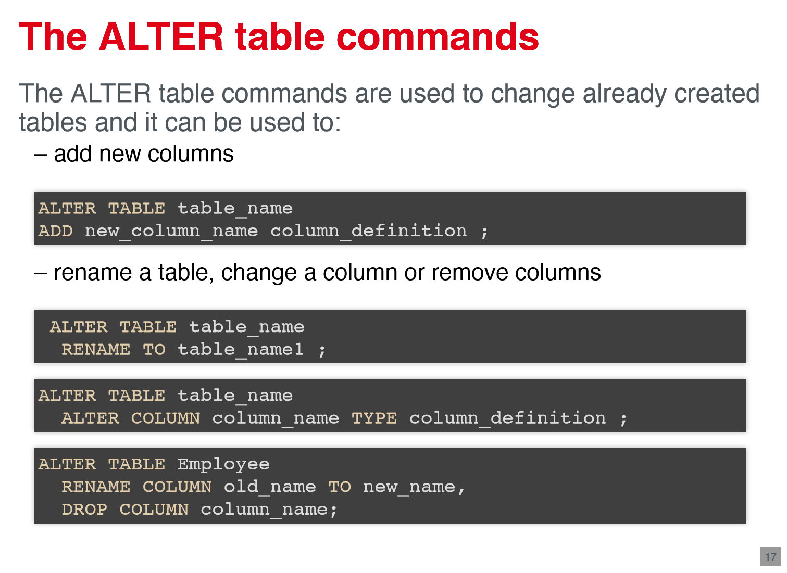

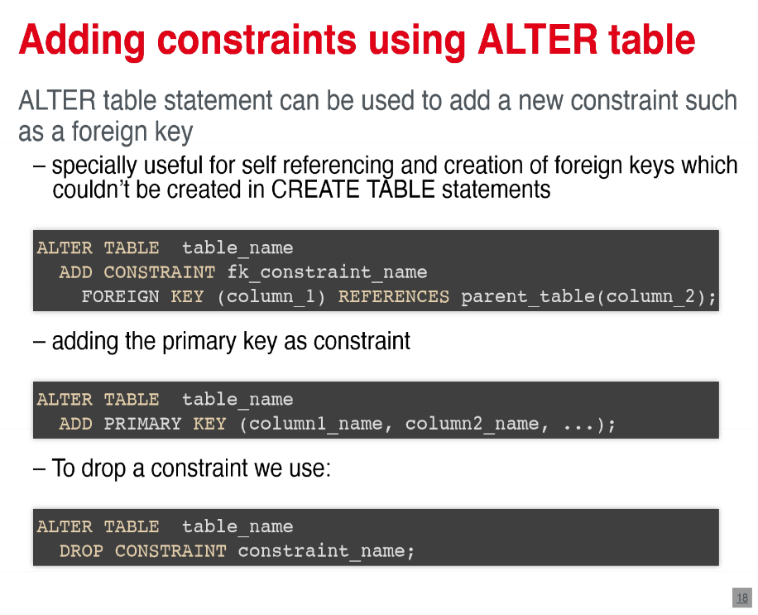

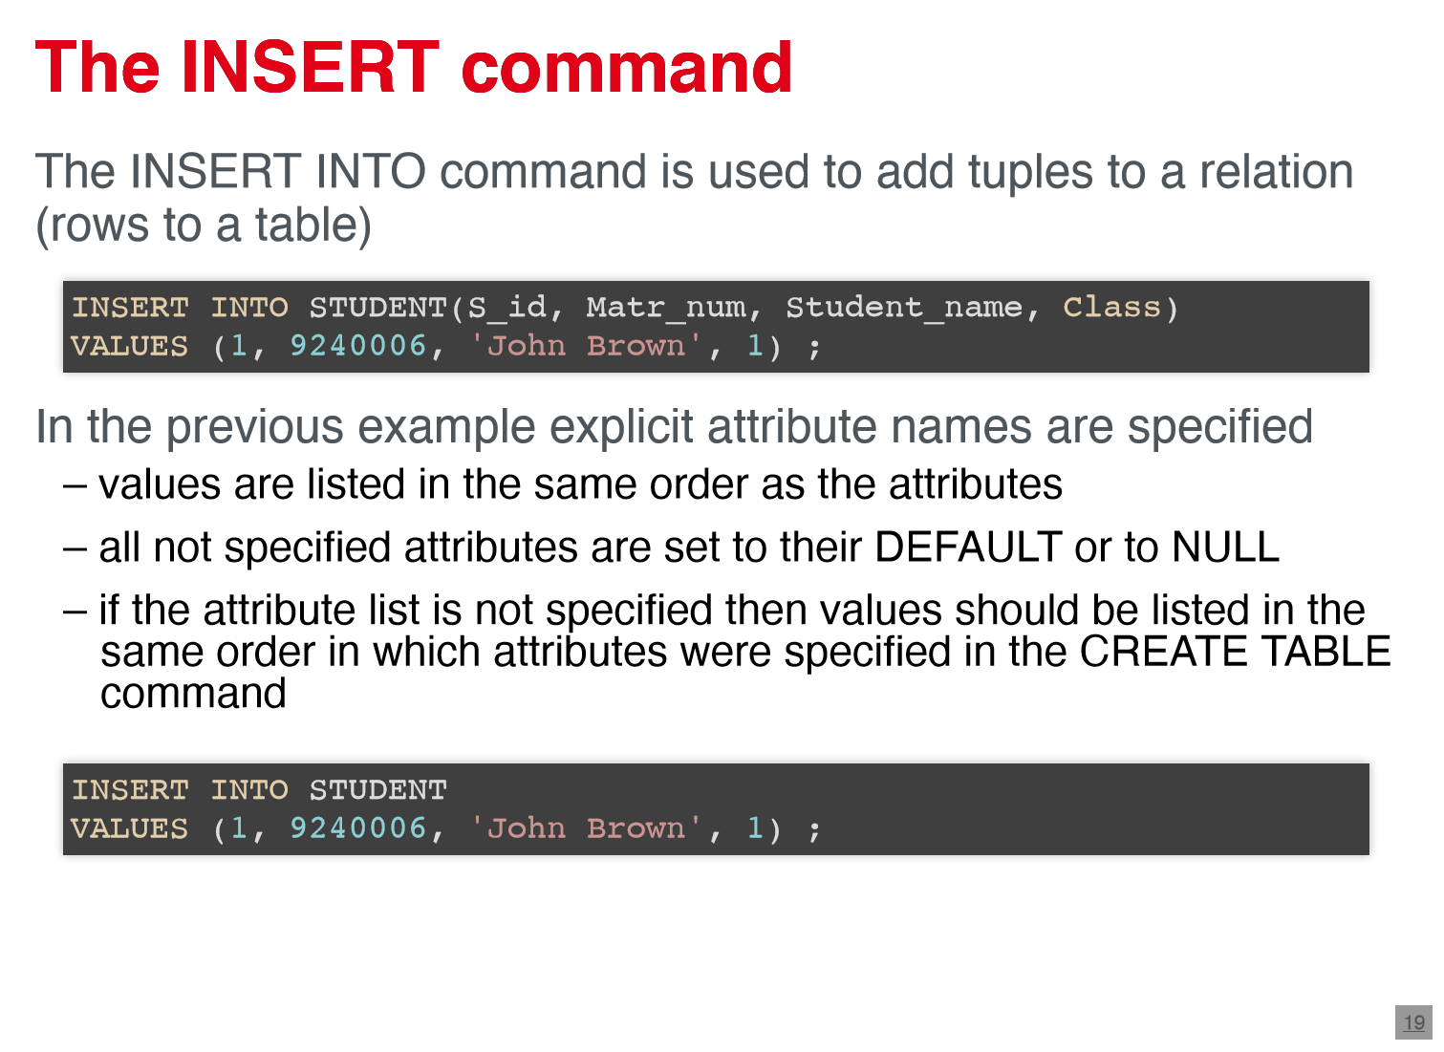

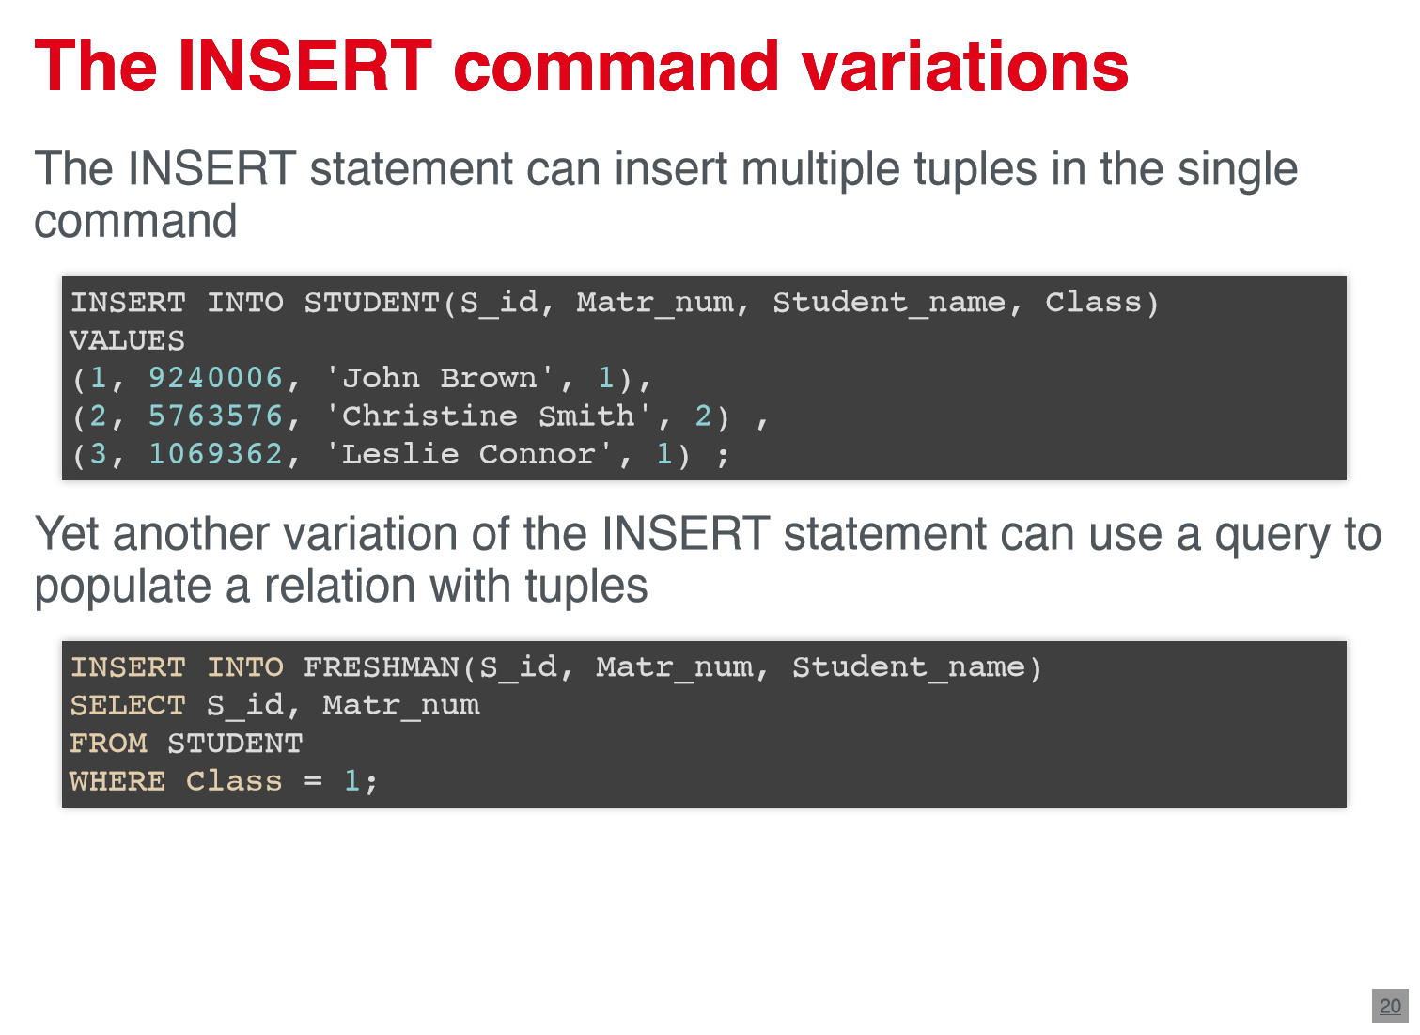

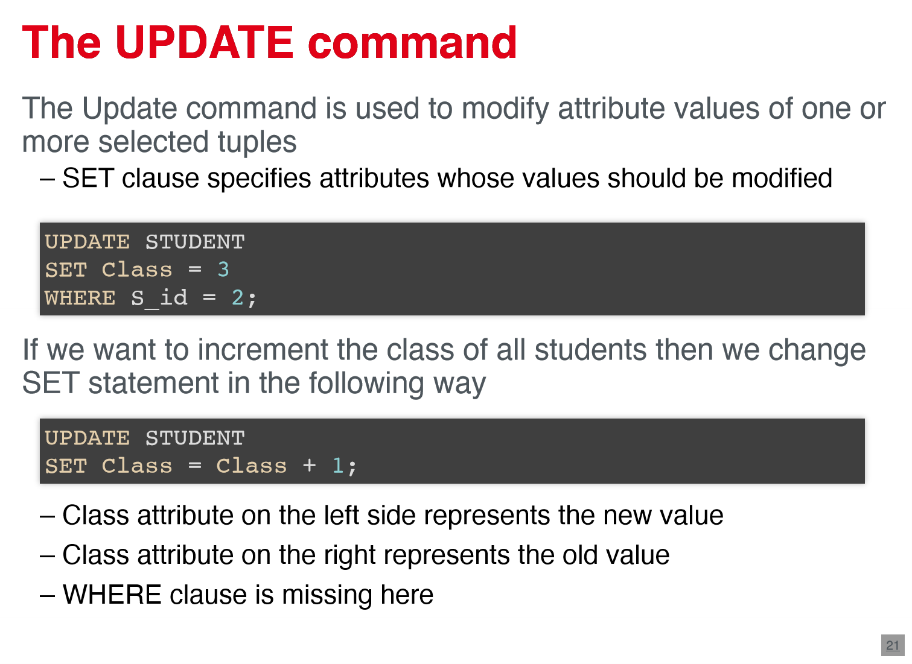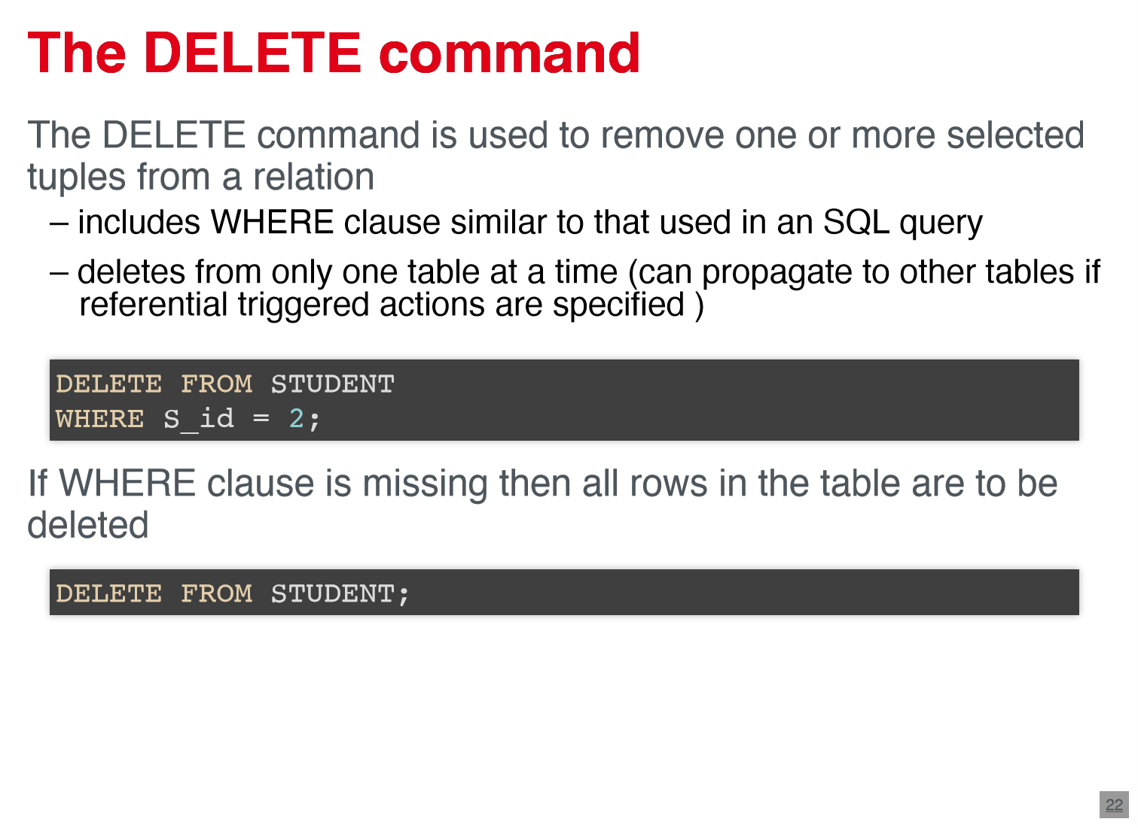

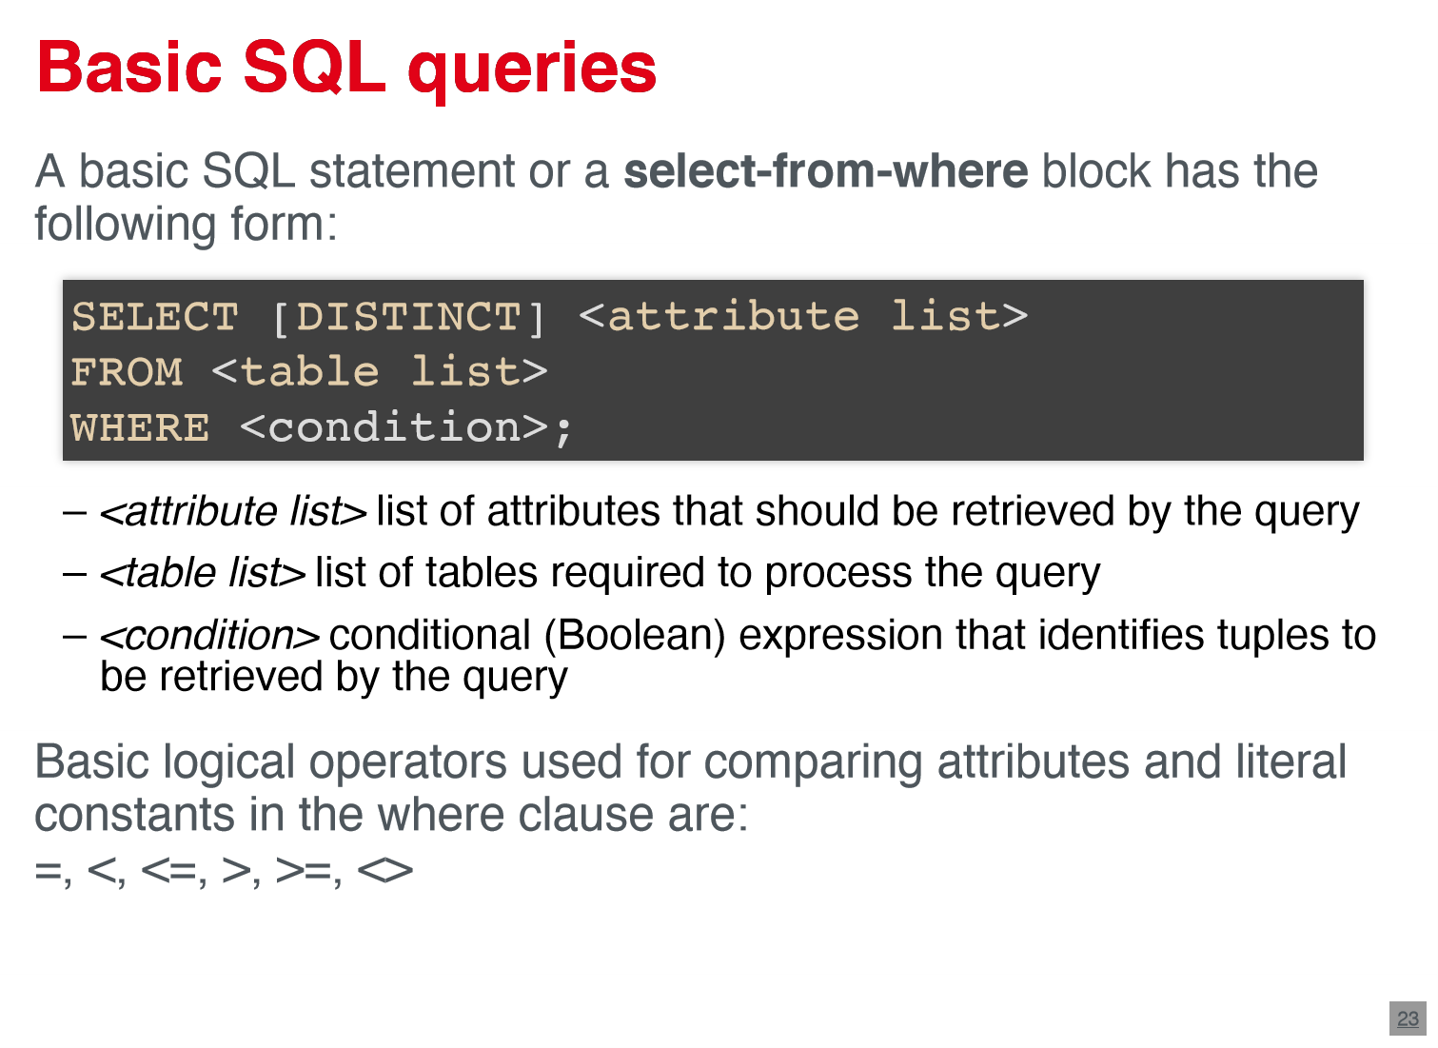

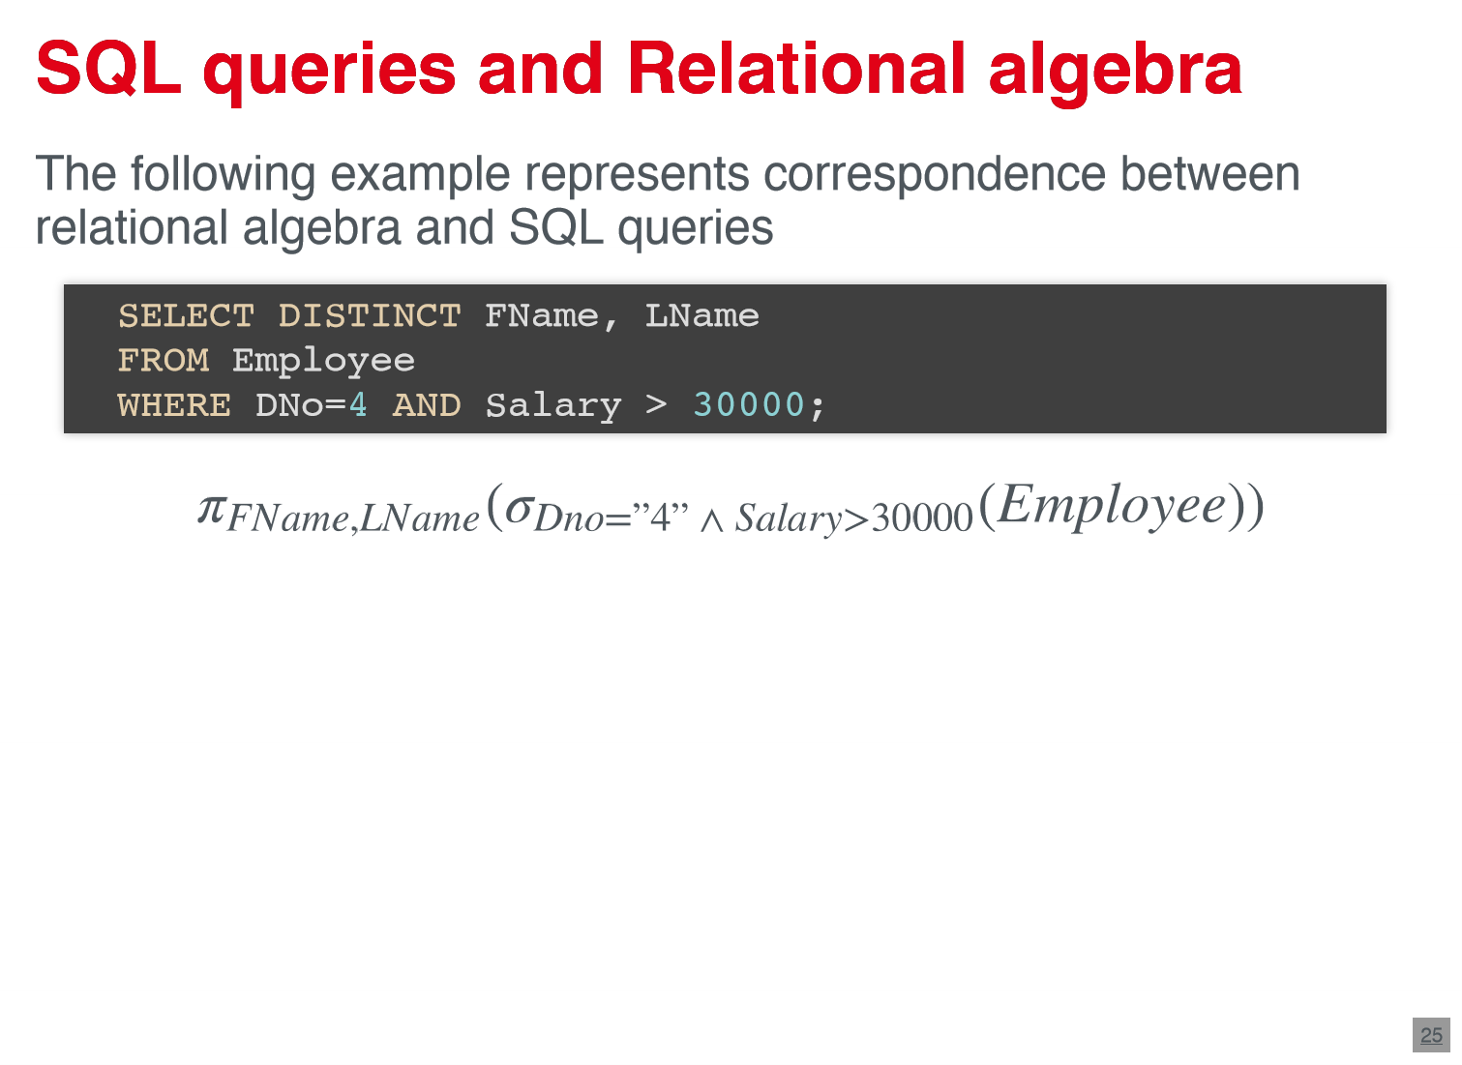

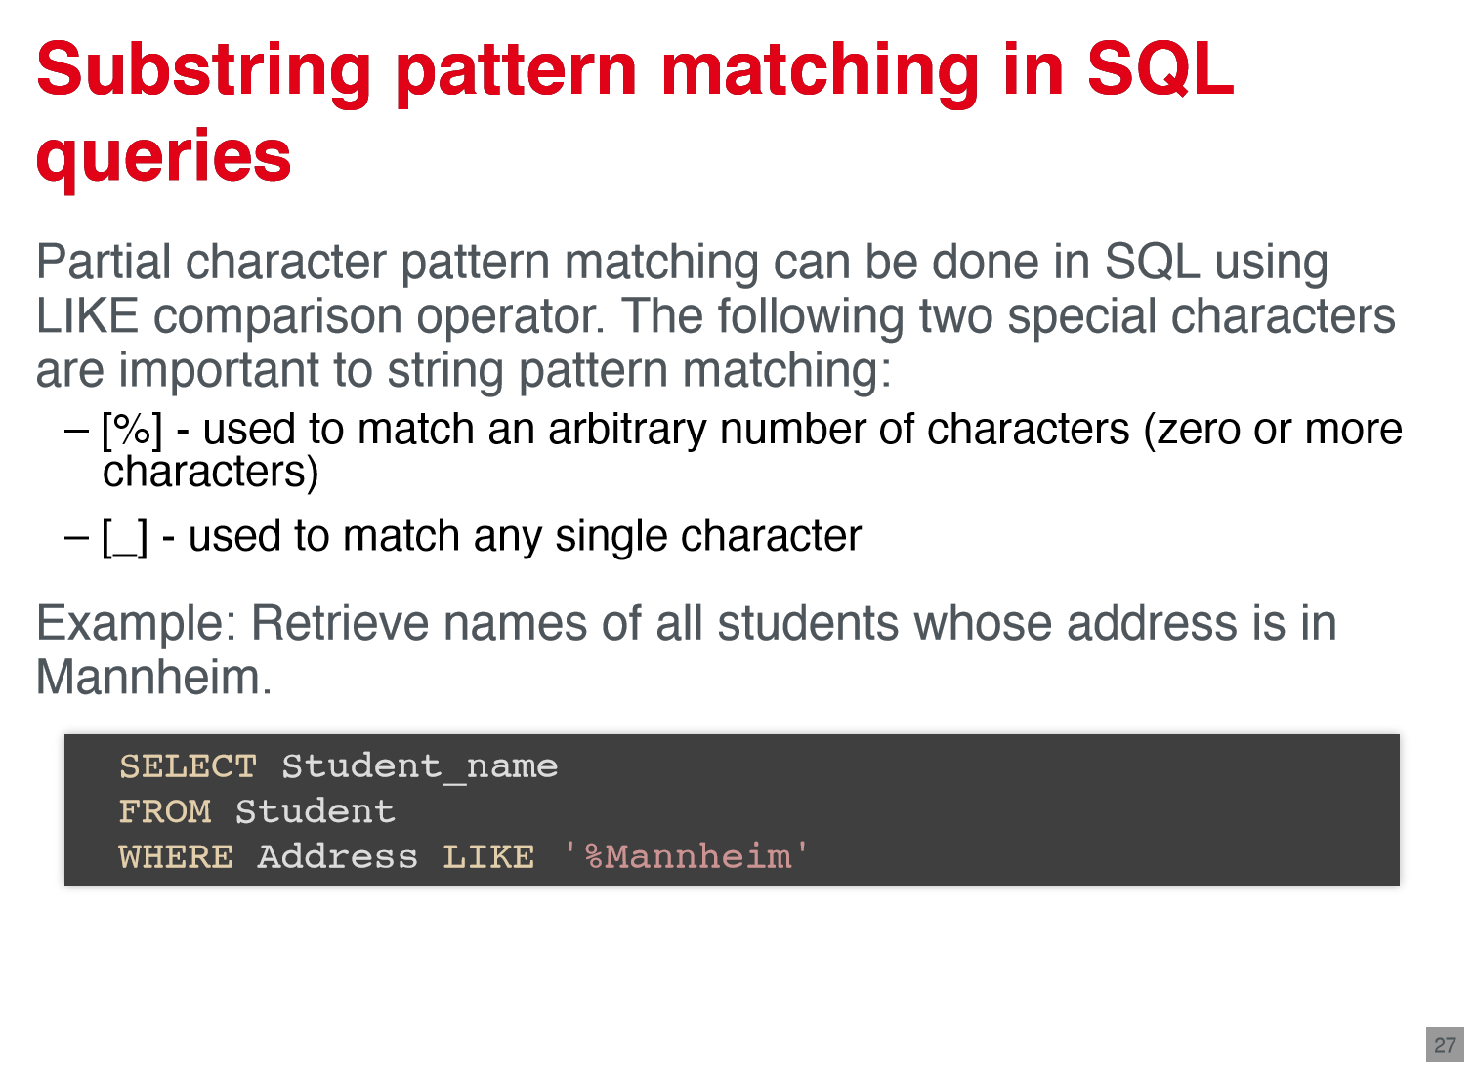

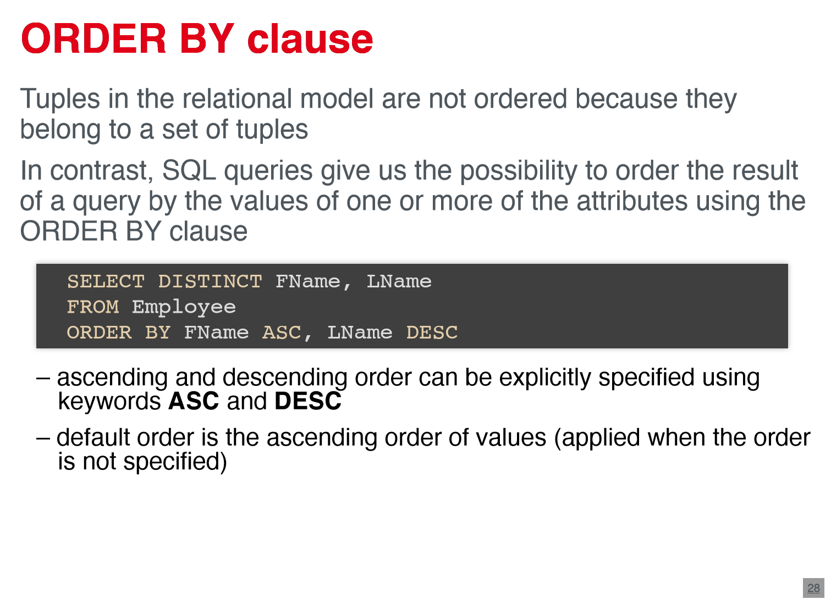

**2.4. SQL queries**

* Basic SQL statement : SELECT – FROM – WHERE
* SELECT = projection operator
* WHERE clause contains conditions
* DISTINCT clause eliminates duplicates
* Without WHERE-clause, all tuples are returned
* SELECT * returns all attributes
* LIKE: partial matching
  + [%] – used to match an arbitrary number of characters
  + [_] – used to match any single character
* ORDER BY clause Can order the result of a query by the values of one or more attributes
  + ASC = Ascending, DESC= Descending (default is ascending)

**2.5 Operations**

* Rename operation : rename relations and attributes in SELECT or FROM-clause
* Set operations : UNION; INTERSECT; EXCEPT : result: set up values without duplicates -> only on a union compatible relations (attributes with same domains and order)
* cartesian product operation : create a list of all pairs of elements from 2 relations
* join operation : join two relations on special columns

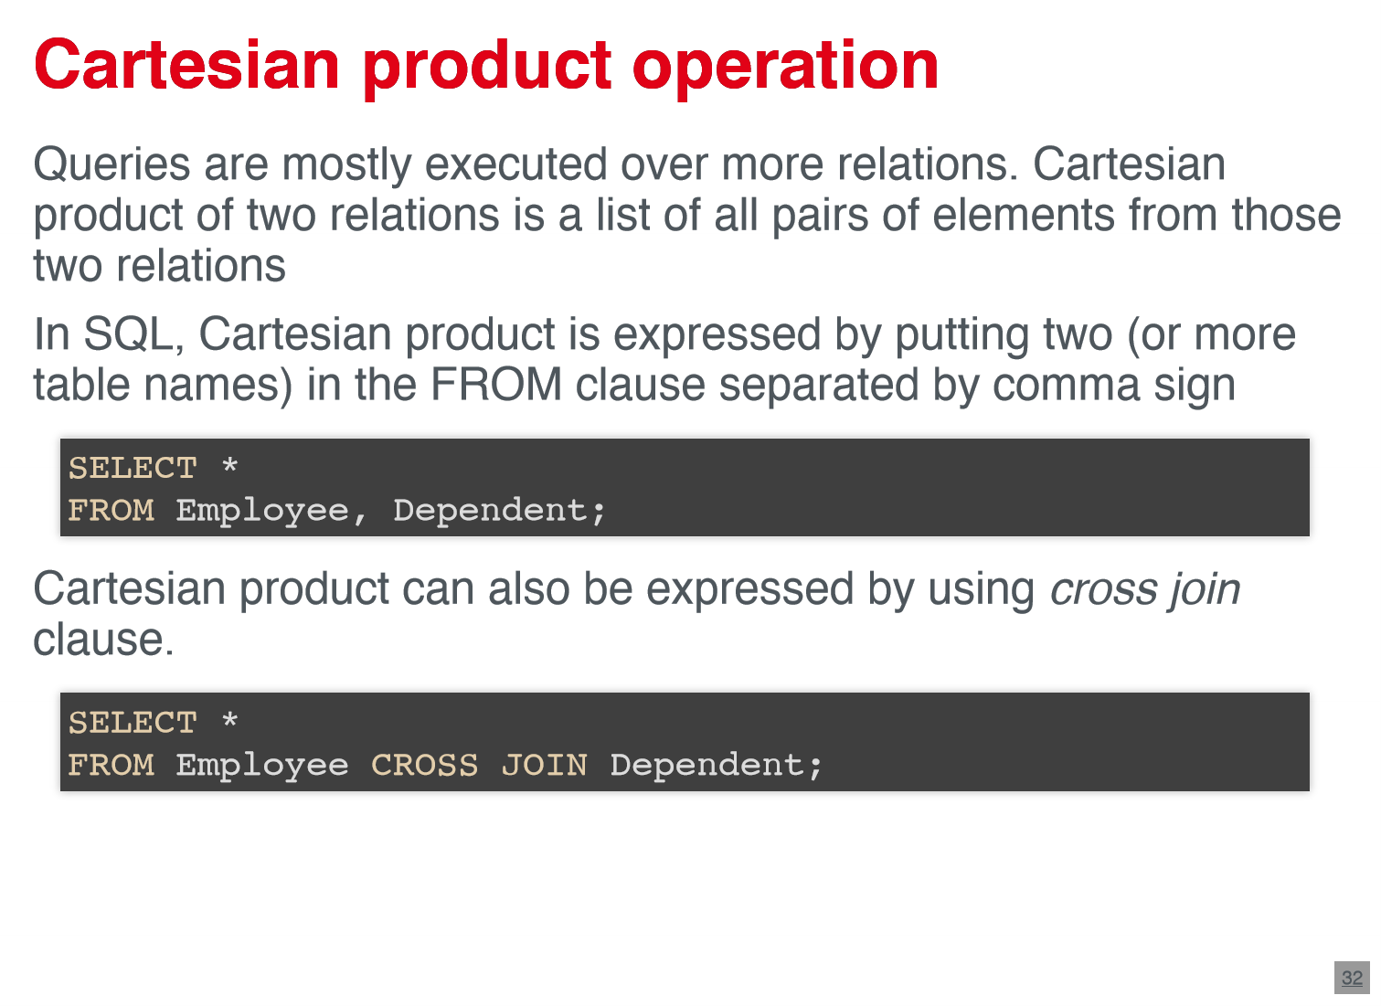 

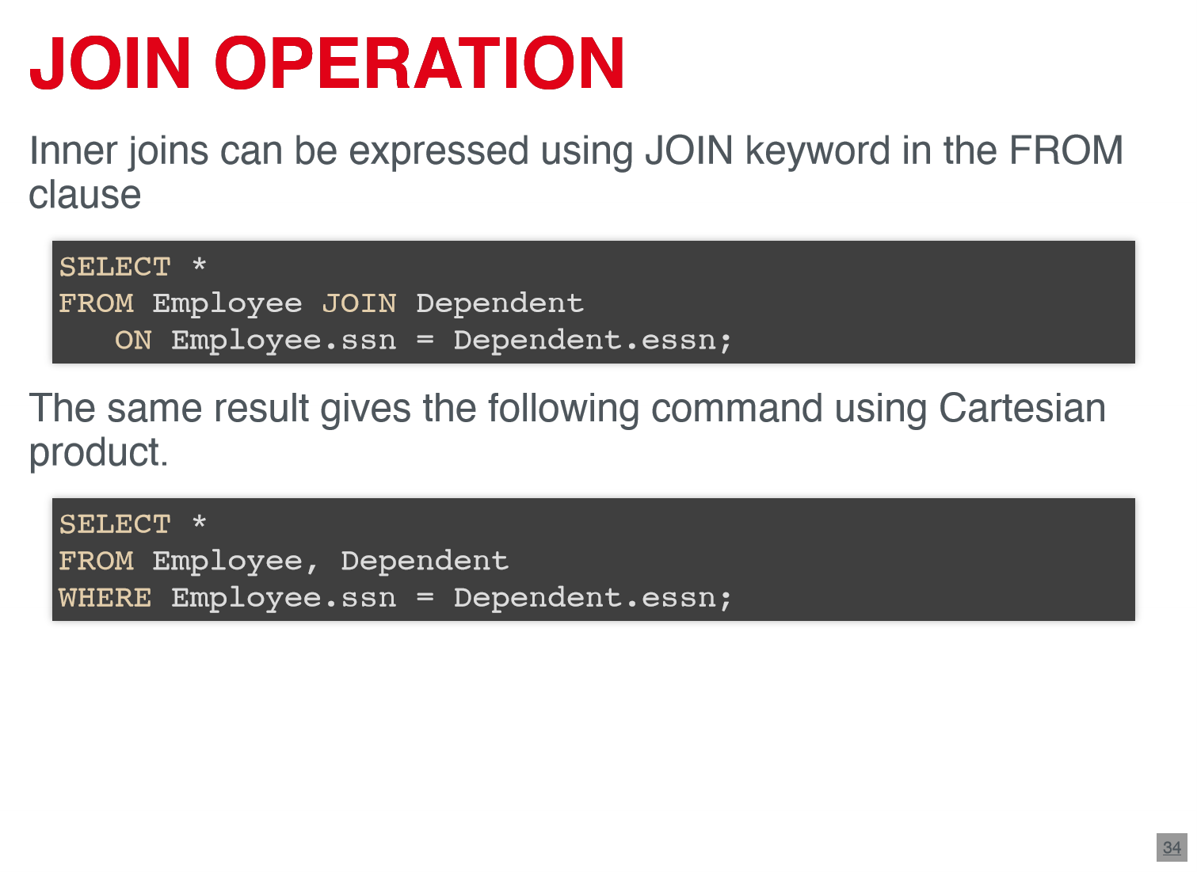 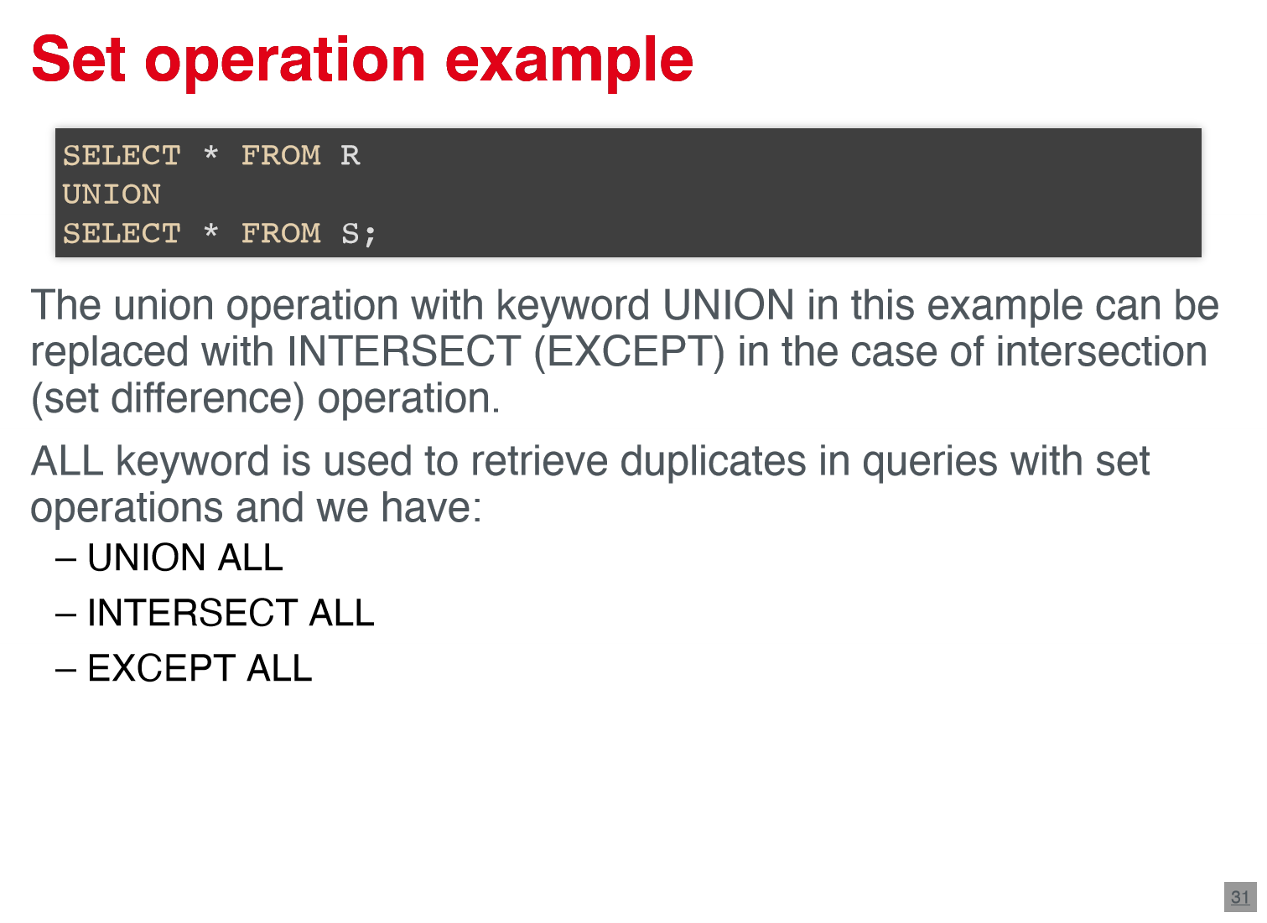

**2.5.1 different types of joints**

* INNER JOIN: same result as JOIN
  + ON- statement can be defined with operators : =,<,>,<>
  + Theta-join in relational algebra

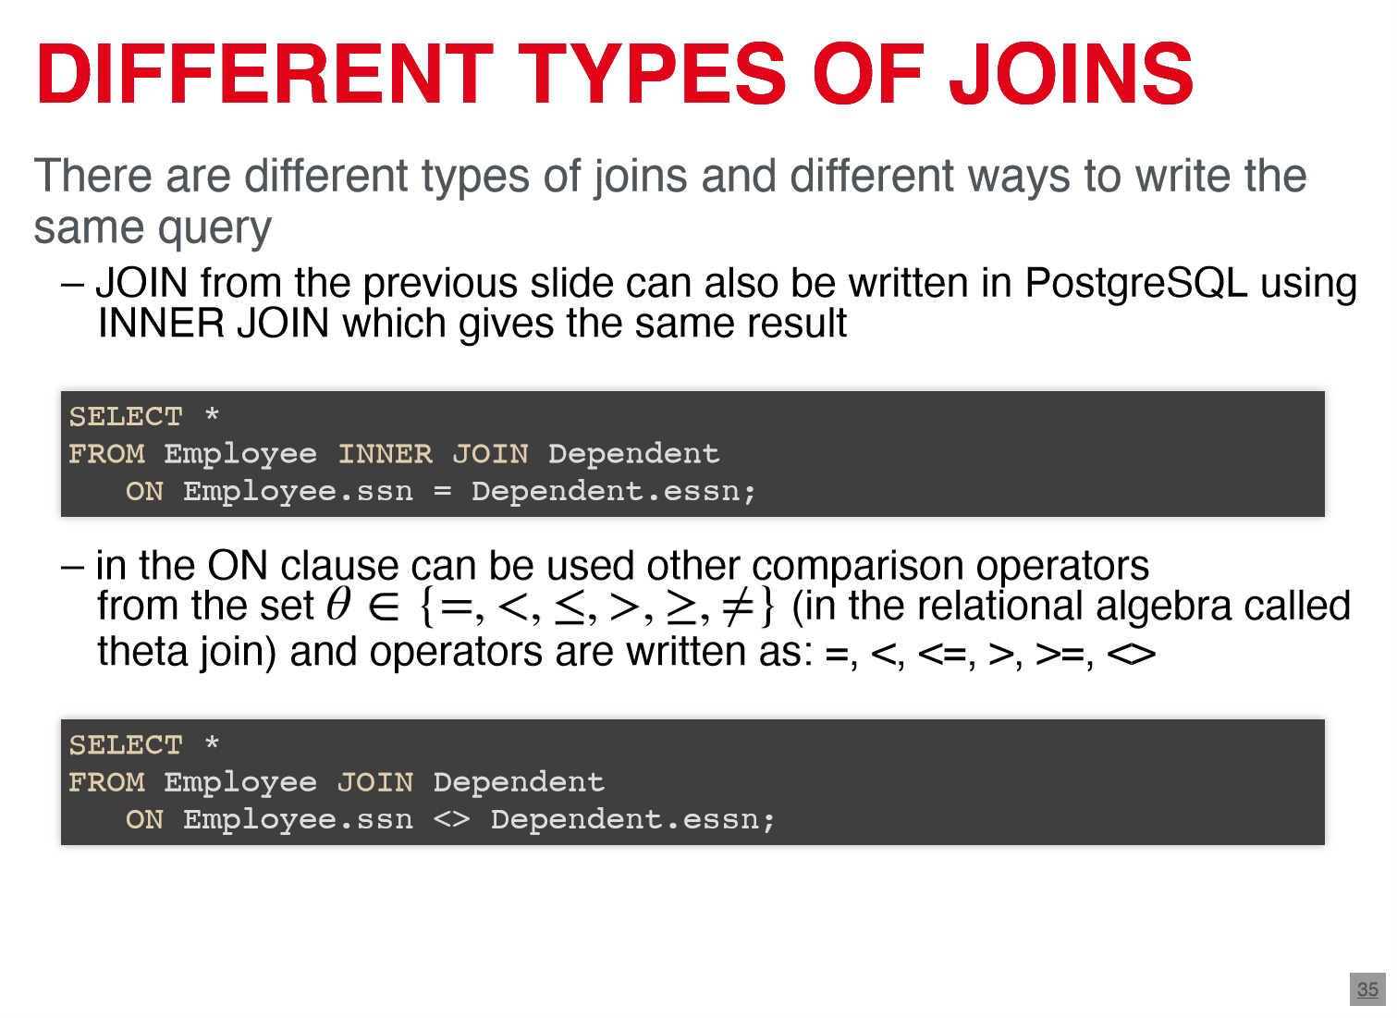

* OUTER JOIN: LEFT JOIN, RIGHT JOIN
  + holds all instances from left or right side

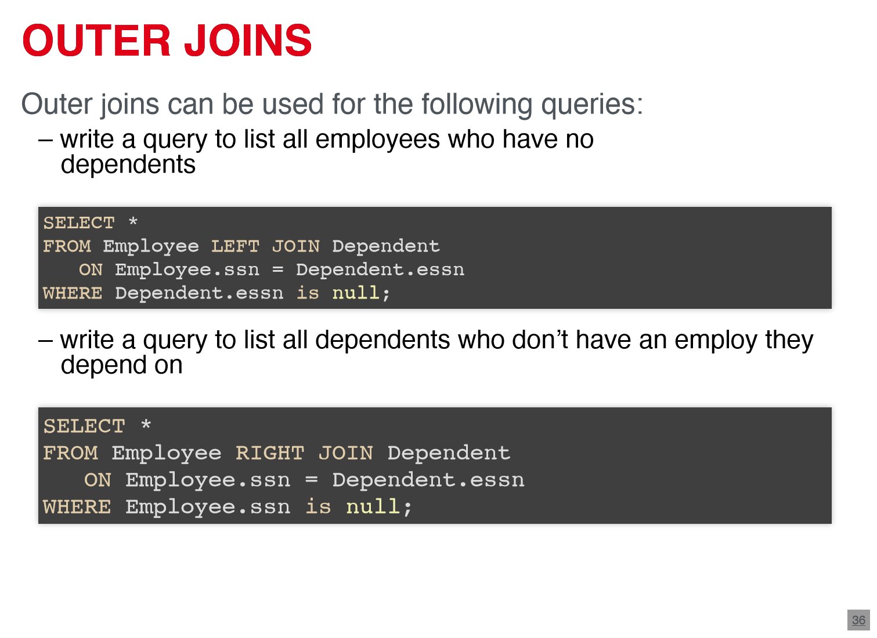

* SELF JOIN: join of table with itself

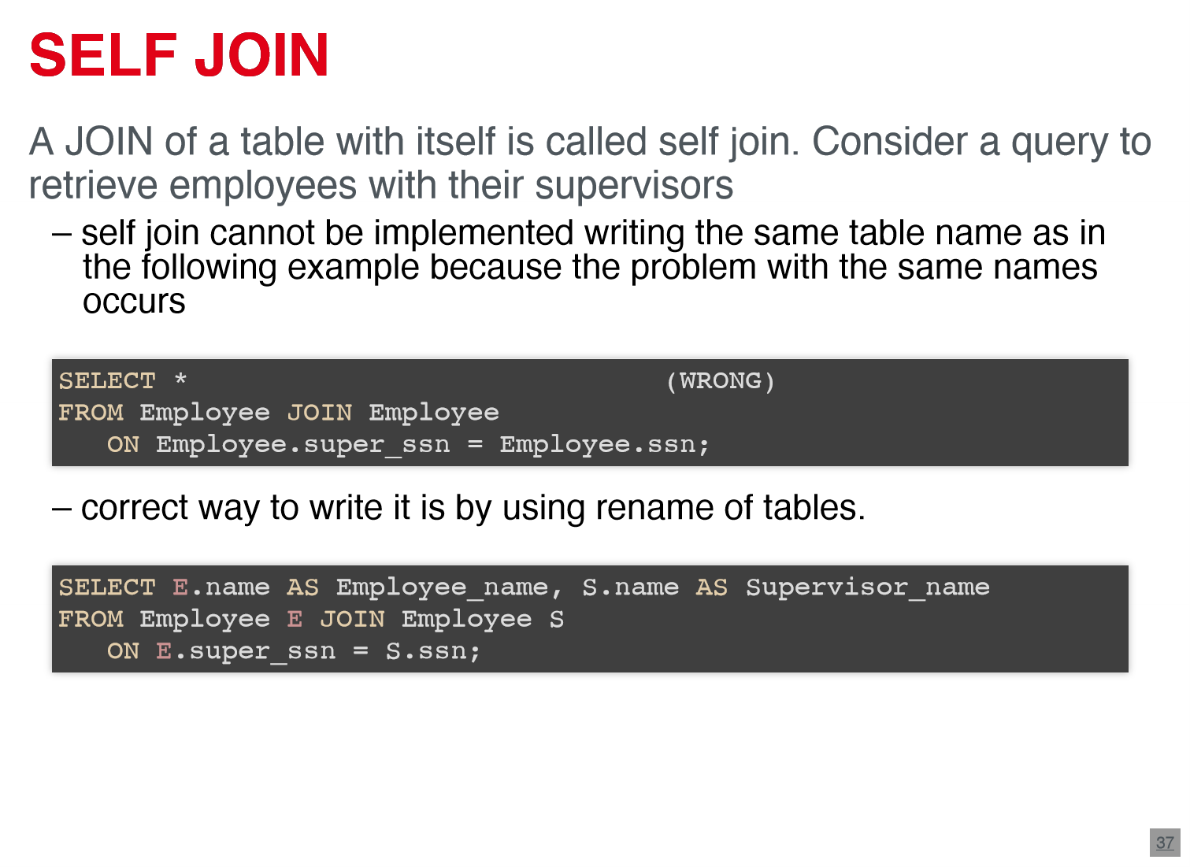

**2.5.2. Operators for nested queries**

* nested queries are used when careers require that existing values be fetched and then be used in comparisons
  + nested query and outer query
  + operators : IN, ANY, SOME, ALL, EXISTS

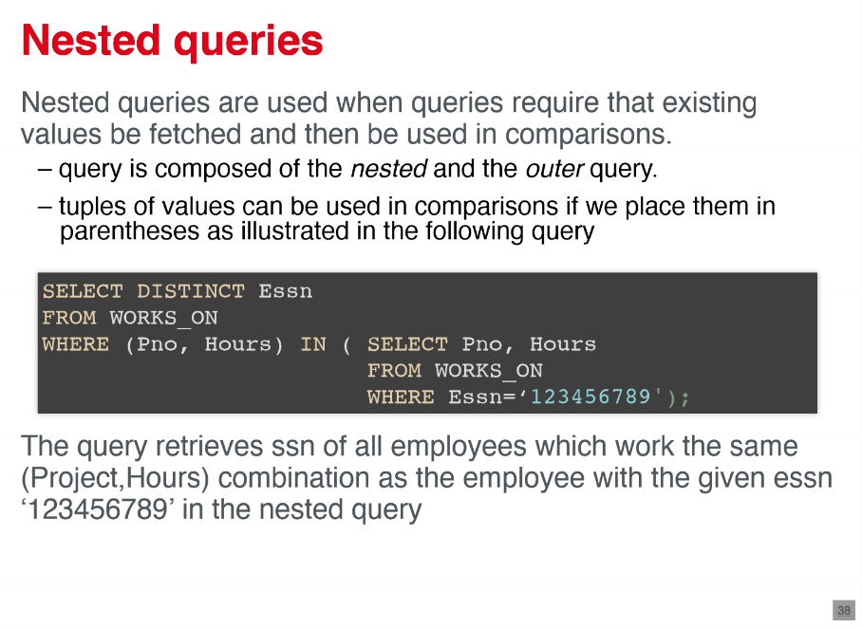 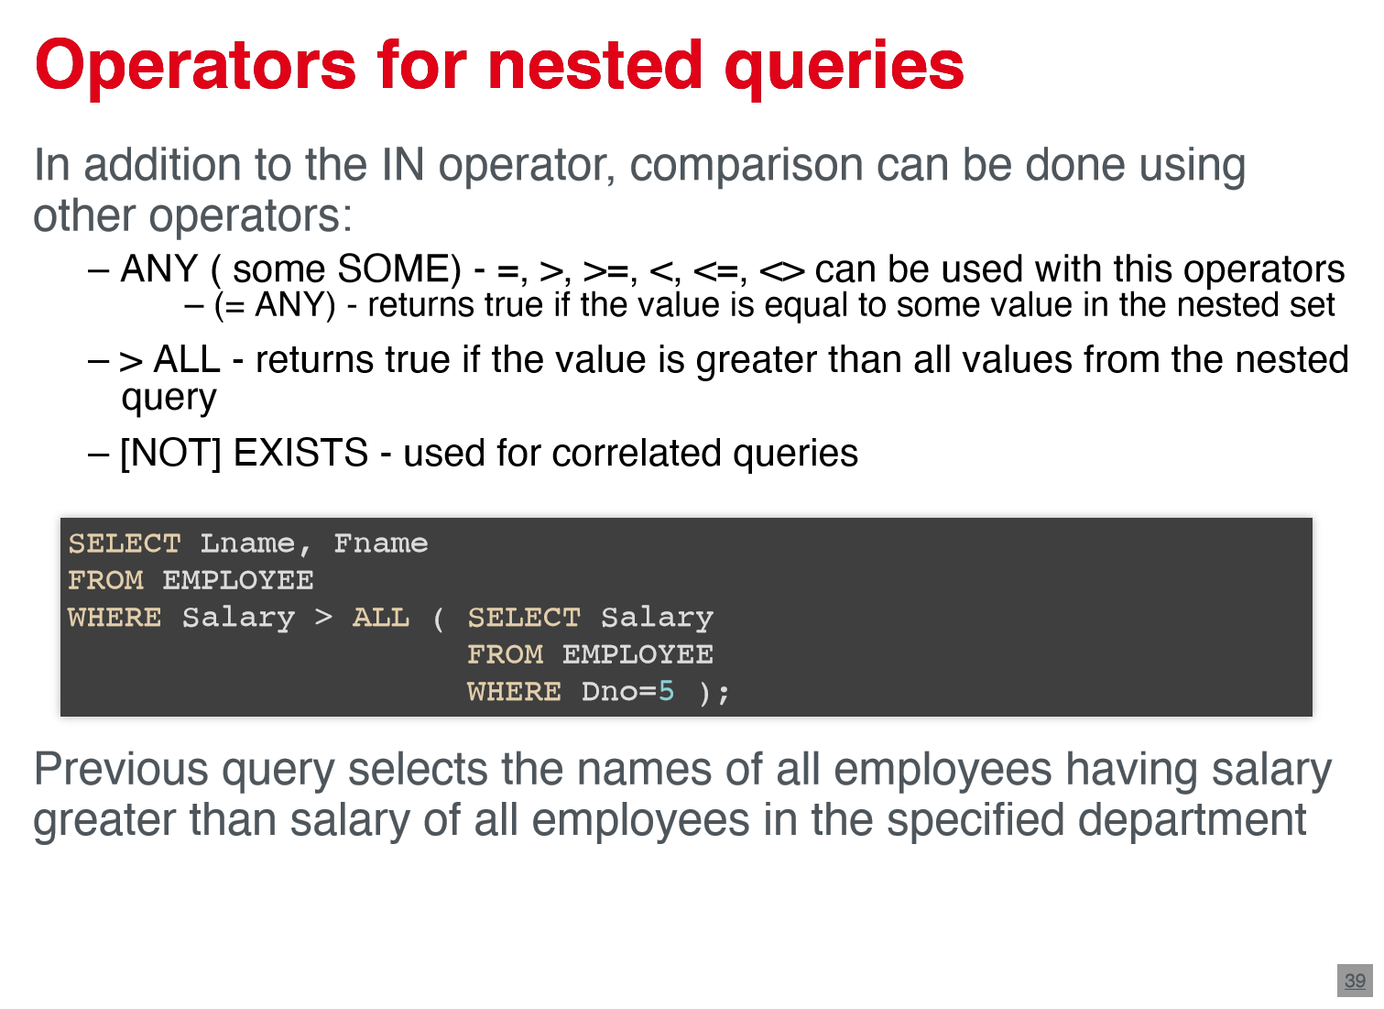

**2.5.3. Grouping and aggregation**

* aggregate functions summarize data from multiple tuple into a single one – COUNT; SUM; MAX; MIN; AVG
* GROUP BY Is used to group tuple according to different attribute values

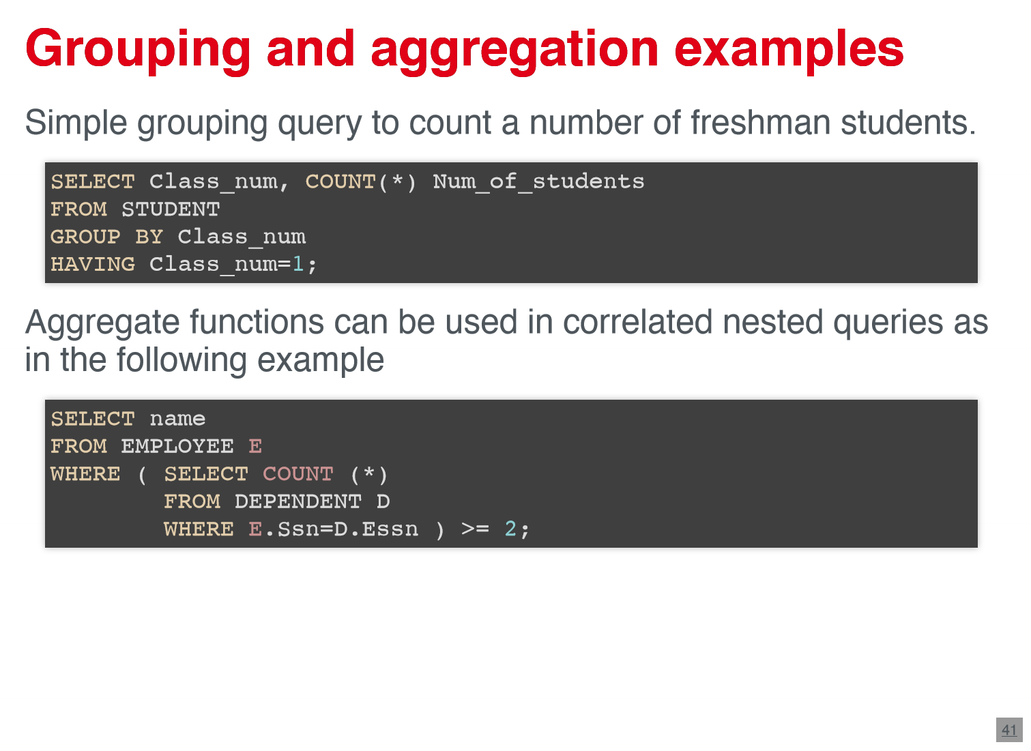

**2.6. Miscellaneous**

* View: is a virtual table derived from one or more other tables or views (not necessarily physically stored) -> update operations are limited ->queries are specified the same way
* indexes : are a part of physical organization of a database -> improve speed of data retrieval
  + unique constraint (index )is automatically created by the definition of a primary key
  + partial index contains only part of the table ; created by using WHERE-clause
* stored procedures and functions : are code elements , which extent plain SQL the procedural elements , i.e. control structures , loops and complex calculations
* triggers : our start procedures which are automatically invoked , when a special event in the database occurs

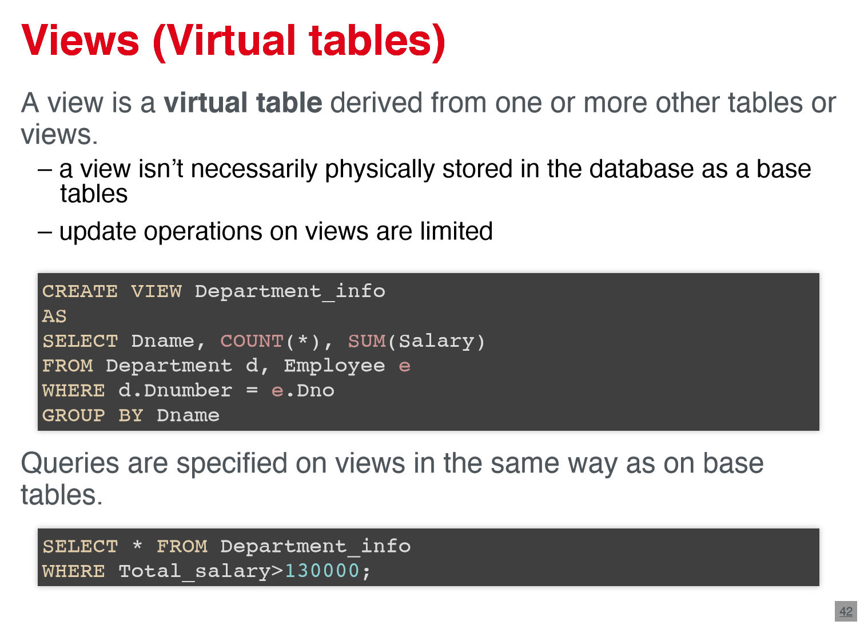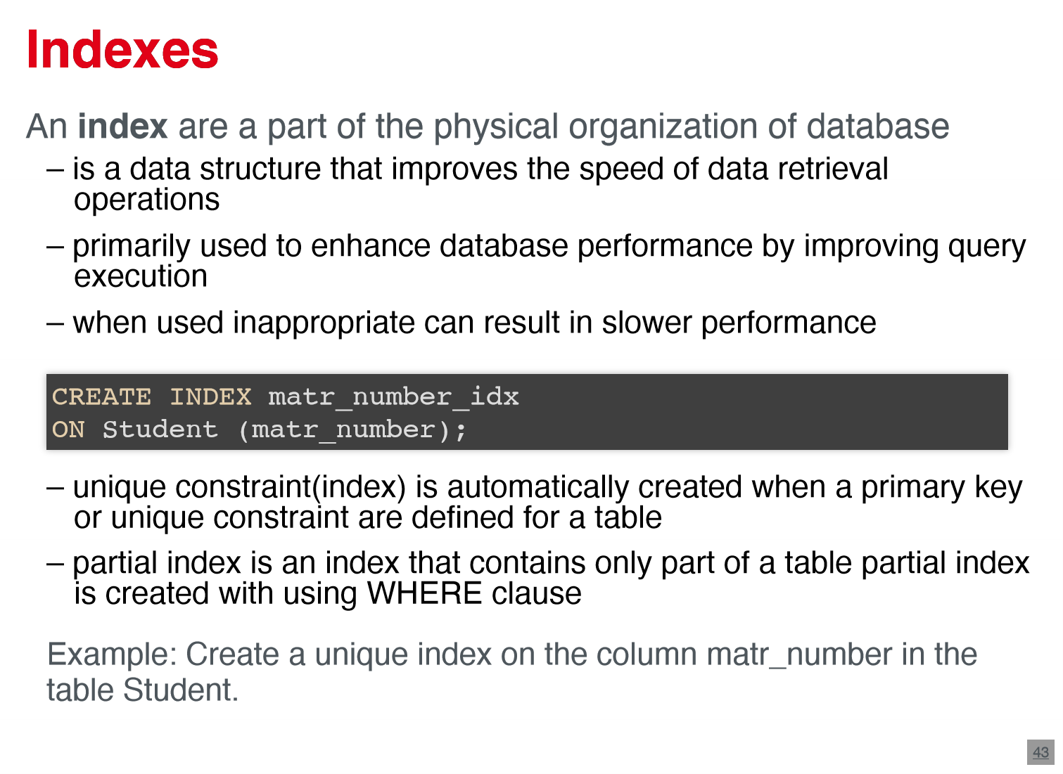

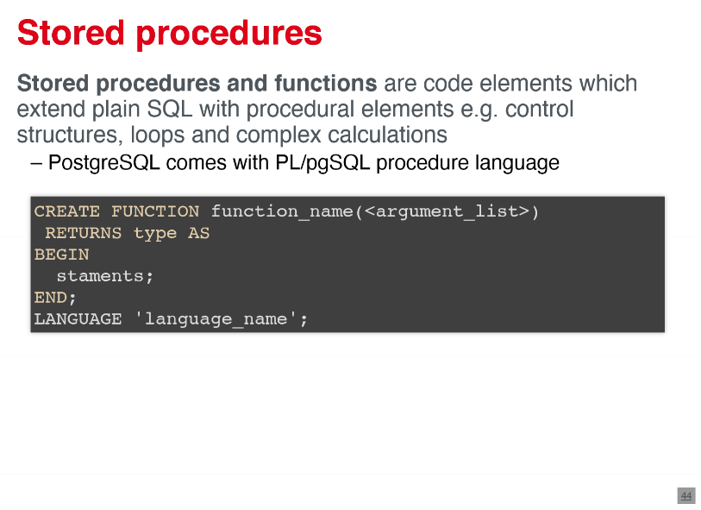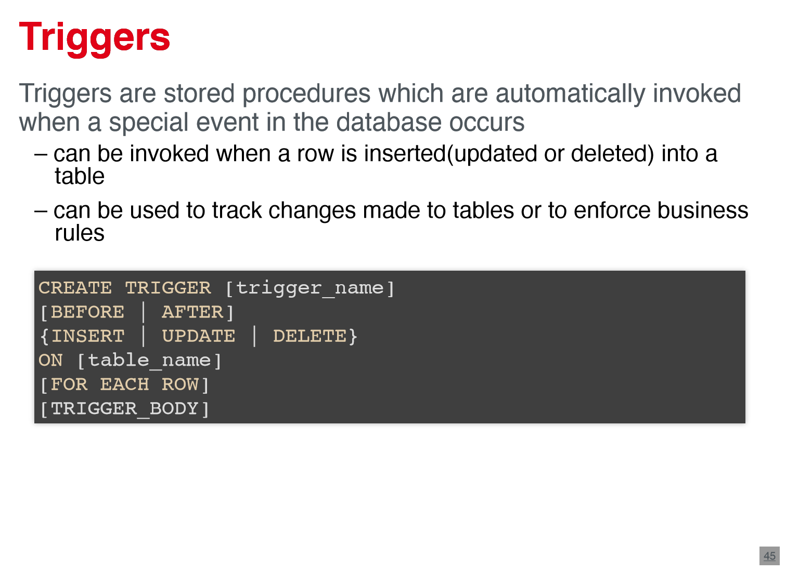

1. **normalization**

* normalization = cross of structuring a relational database in accordance to series of rules – called normalforms
* tests are applied on relations -> if they don't meet requirements they are decomposed to smaller relations
* decomposition should preserve :
  + non additive join or lossless joint property
  + dependency preservation property
  1. **guidelines** 
     1. **informal design guidelines**
* clear semantic for attributes in relational schema
* reduce redundant information in tuples and NULL values
* no spurious data
  + - 1. **problems with too big and too small relations**
* too big:
  + writing queries is easy but they suffer from anomalies
  + mixing of multiple entities -> semantic ambitious
  + many NULL values when attributes do not apply
* too small :
  + writing queries is costly with many joins
  + semantics of entities is decomposed
    1. **general guidelines**
* avoid anomalies - mixing attributes from distinct entities
* avoid placing attributes whose values may frequently be NULL
  + selection , Join and aggregation is complicated with NULL
* avoid join by matching attributes that are not primary key foreign key combinations -> avoid spurious tuples
* guidelines are sometimes violated to improve efficiency of queries

**3.1.2.1 Anomalies**

* Anomalisa consequences of inappropriate database design -> insertion, deletion, update
* i.e. inserting a new curse with no students -> NULL values for students -> violation of primary key constraint
* changing name of course requires changing in all tuples -> typos lead to inconsistency
* delete in a student -> loss of information for the course too

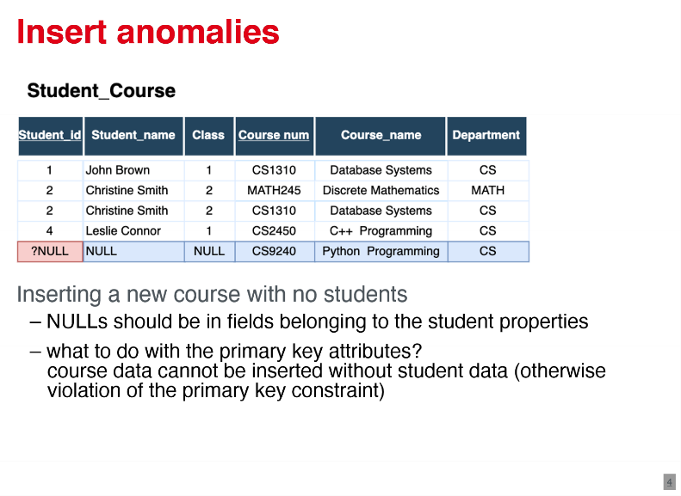

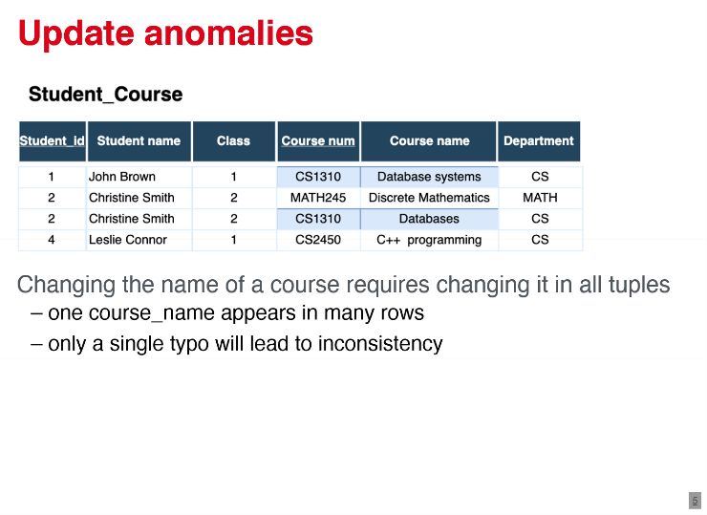

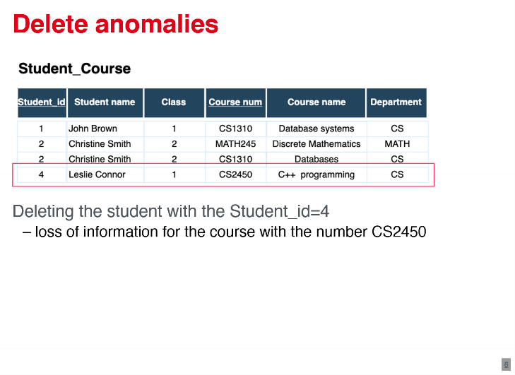

**3.2 Normal forms**

* Normal forms Are roots for a good database design -> based on functional dependencies and multivalued dependencies
* in practice relation should satisfy 3NF or BCNF or at most 4NF

**3.2.1 functional dependencies**

* trivial functional dependency : A → B B ⊆ A
* non trivial functional dependency : A → B B ⊈ A
* completely non trivial functional dependency : A → B A ∩ B = ∅
* important to differentiate key and non key attribute
* set up attributes X and a set of function dependencies F -> closure of X under F is a set of all attributes that are functional dependent on X

**3.2.2. first normal form (1NF)**

* domain of each attribute has atomic values
* value of any attribute in a tuple is a single value from the domain
* 1NF disallows nesting of relations ; excludes multivalued and composited attributes

**3.2.3 second normal form (2NF)**

* 1NF+ every non key attribute is fully functional dependent on a key of R
* Functional dependency X->Y is the full functional dependency if the dependency doesn't hold if we remove any attribute from X -> Else is a partial functional dependency
* normalization by decomposition of relation

**3.2.4 third normal form (3NF)**

* 2NF+ No non key attribute of our which is transitively dependent on a candidate key
* transitive functional dependency :
* decomposition :
* alternative definitions :
  + every non key attribute is fully functional dependent and non transitively dependent on every key
  + every non trivial functional dependency X->A: X is a super key or A is key attribute

**3.2.5. Boyce-Codd normal form (BCNF)**

* for every non trivial functional dependency X->Y, X is a super key of R ; alternative : no attribute is transitively dependent on a candidate key ; alternative : only non trivial functional dependencies are key constraints

**3.2.6. 4th normal form (4NF)**

* for a set of dependencies F (functional and multivalued ) every nontrivial multivalued dependency X->>Y, X is a super key
* multivalue dependency X->>Y , where x,Y c R and Z=R-(X u Y), Hertz if all combinations are existent : if X->>Y and Y->>Z, than X->>Y/Z
* if X->>Y/Z hold, Then the decomposition splits it attributes in two relations R1(X,Y), R2(X,Z)

